

Table of Contents
The Mighty PREMIUM Checklist, for Project Mentors and Coaches 4
1. Important programme information 8
  - The PREMIUM student profile 8
  - Learning objectives 8
  - Student time investment PREMIUM 9
  - Mandatory character of the programme 9
    - Exceptional circumstances 9
  - Address issues timely 9
  - Assessment 10
    - Assessment criteria 10
  - Responsibly using AI during PREMIUM 10

- Central Events 12
  - The Mix & Match Kick-Off Event 12
  - Midterm Presentations 12
  - The PREMIUM Closing Event 14

- The role of the Client and Project Outcome 16
  - The Client 16
  - The final product and end results 16
  - Project budget 17
    - Reimbursement of Travelling Costs 17

- The role of the Team, Project Mentor and Coach 18
  - The role of the Project Mentor 18
  - The role of the Coach 19
    - Individual Coaching Meetings 19
    - The Personal Development Plan (PDP) 20
    - A PREMIUM Coach’s attitude 20
  - The Student team 21
    - Peer Feedback “Watering Flowers” and “Reflections for the Future” 21
    - Project related team tasks 23

- Structure of set meetings throughout the programme 24
  - Kicking off the project and team journey 24
    - Project Kick-Off Session, initiated by Project Mentor 25
    - Team Kick-Off Session, initiated by Coach 25
  - Midterm Milestone Meetings 28
    - Midterm Project Review meeting, initiated by Project Mentor 28
    - Team Dynamics session, initiated by Coach 30
  - Closing session with Client 32

- Team issues and challenges 33
  - Most common challenges you will encounter during PREMIUM 33
  - Self-determination theory; enhancing or undermining motivation 35
  - Lencioni’s five dysfunctions of a team 37
  - Tools and games available at EDLAB 37

- Coach and Mentor training programme 39
- Compensation 40
- Contact information 41

APPENDIX I: Form Project Scope, Success Criteria and Timeline 42
APPENDIX II: Guideline for setting up a budget 46
APPENDIX III: Team Charter 47
APPENDIX IV: PREMIUM Midterm Project Review form 52
APPENDIX V: Midterm Peer feedback form “Watering Flowers” 55
APPENDIX VI: Final Peer Feedback form “Reflections for the Future” 59
APPENDIX VII: Student checklist with deadlines 61
APPENDIX VIII: Basic emotions 64
APPENDIX IV: “The 24/7 student & the perfect student 65
APPENDIX X: Mirroring 68

The Mighty PREMIUM Checklist, for Project Mentors and Coaches
Below, we provide you with an overall checklist that you can follow for every task, to ensure you and your students will remain on track. It will provide you with more direction into when certain deadlines are. In the appendix, you can find the checklist with deadlines your students need to take into account.
Project Mentor Checklist
- Training Programme for Coaches and Mentors
  - Check the voluntary trainings on offer at EDLAB and sign up via https://edlab.nl/excellence/premium/premium-coaches-and-mentors/
- Project Kick-Off Session (Deadline: Friday February 6th)
  - Schedule in accordance with the Client and students, your team’s Project Kick-Off session to discuss the project's foundational elements; its content and objectives.
  - Set up a plan for your meetings with the students and how they update you.
  - Make clear agreements with the client on how to keep each other updated on the team’s progress.
- Team Kick-Off Session (Deadline: Friday February 6th)
  - Together with your Coach and students, schedule and facilitate your team’s Team Kick-Off session to discuss how the team will work together.
  - Check that you received your team’s filled out Team Charter after the meeting.
  - Make clear agreements between Mentor and Coach on how to keep each other updated on the team’s progress and potential issues.
- Budget (Deadline: Friday February 6th)
  - Have your students set up a preliminary budget describing the costs they expect to make throughout the project.
- Form “Project Scope, Success Criteria and Timeline” (Deadline: Friday February 13th)
  - Check that your students fill out the form “Project Scope, Success Criteria and Timeline”, to help them negotiate their project scope and set up a project timeline.
  - Provide feedback to your students on their plan, and circle back to the client. Make sure expectations are aligned.
- Instagram page (Deadline: Friday February 13th)
  - Follow your team’s Instagram page (optional).
  - Check that your students share on your team’s Instagram page the following, in order to inform their peers about their team’s PREMIUM journey ahead:
    - Introduce the team members;
    - Introduce the client and the project (the scope, relevance of the project, what is asked of you).
- Second Instagram post (Deadline: Monday March 2nd)
  - Check that your students share on your team’s Instagram page the preliminary timeline for your project.
    - Explain what is their first approach to the issue at hand;
    - Present the main steps that they are planning to follow in tackling the problem;
    - Present their preliminary methodology.

- Third Instagram post (Deadline: Friday March 13th)
  - Check that your students share on your team’s Instagram page their progress so far and relevant updates regarding the project (in line with a potential NDA!). This will be the main point of reference for the teams providing you feedback during the Midterm Presentations.
- Midterm Presentations (Deadline: Monday March 16th, 09:00hrs.)
  - Check that your students send in their PowerPoint presentation before the deadline.
  - Attend the Midterm Presentation session your team is assigned to (March 18th or 19th).
- Midterm Project Review Meeting with Mentor (Between March 9th and April 17th)
  - Check with the Coach when the Team Dynamics Session is scheduled, and make sure you receive your students’ Peer Feedback forms (just for your information, the Coach will discuss it during the Team Dynamics Session).
  - Schedule and facilitate the Midterm Project Review Meeting with your students.
  - Check that you received a filled out Midterm Review Form from each of your students at least 48 hrs before the meeting.
  - Discuss the “don’t agree” statements during the meeting.
  - If your team’s Team Charter is supposed to be adapted after the meeting, check that your students send you the revised version.
- Closing session with the client and Mentor
  - Schedule and prepare a closing session with the client together with your students in which they present their final deliverable and reflect on the entire experience.
- PREMIUM Closing Event (Deadline: Tuesday May 26th, 09:00 hrs.)
  - Check that your students send in their final report, product, or other form of project outcome to you, before the Closing Event.
  - Check that the student team emails the digital file of the video to you and to premium@maastrichtuniversity.nl.
  - Attend the Closing Event on May 28th to support your students.

Coach Checklist
- Training Programme for Coaches and Mentors:
  - Check the voluntary trainings on offer at EDLAB and sign up via https://edlab.nl/excellence/premium/premium-coaches-and-mentors/
- Team Kick-Off Session (Deadline: Friday February 6th)
  - Together with your Mentor, Co-Coach and students, schedule and facilitate your team’s Team Kick-Off session to discuss how the team will work together.
  - Prepare the session and materials you need.
  - Check that you received your team’s filled out Team Charter after the meeting.
  - Make clear agreements between Mentor and Coach(es) on how to keep each other updated on the team’s progress and potential issues.
- Instagram page (Deadline: Friday February 13th)
  - Follow your team’s Instagram page (optional).
- First coaching session (Deadline: Friday February 27th)
  - Schedule and attend your first meetings with your students.
  - Check if you have received their PDP Part 1A and 1B at least 48hrs before your scheduled session with them.
- Midterm Presentations (Deadline: March 18th or 19th)
  - Attend the Midterm Presentation session your team is assigned to.
- Team Dynamics Session (Between March 9th and April 17th)
  - Together with your students, (and co-coach) schedule and facilitate their Team Dynamics Session.
  - Prepare the session and materials you need.
  - Check that you received a filled out Peer Feedback Form “Watering Flowers” for every member of your team about every member on the team, at least 48hrs before the session.
- Second coaching session (Deadline: Friday April 17th)
  - Schedule and attend your second meetings with your students.
  - Agree with your students which components of the PDP (or other logging method) you would like to receive as preparation for the session, and by which deadline.
- Third coaching session (Deadline: Wednesday May 20th)
  - Schedule and attend your third and final meetings with your students.
  - Agree with your students which components of the PDP (or other logging method) you would like to receive as preparation for the session, and by which deadline.
- PREMIUM Closing Event (Deadline: Thursday May 28th)
  - Attend the Closing Event on May 28th to support your students.

Dear PREMIUM Project Mentor or Coach,

Thank you for joining the PREMIUM community (once again) this year. We are very excited to be organizing the PREMIUM programme this year for the 15th time and look forward to a successful, educational and fun PREMIUM season together with you.

PREMIUM is an honours programme for Maastricht University’s excellent master’s students. This extracurricular programme provides an extra challenge for talented students and prepares them for the labour market, aiming to effectively bridge the gap between study and career.

PREMIUM students work on a project for an external client under the guidance of a project mentor and participate in master classes and workshops. Another important element of the programme is the competence coaching. All students work and reflect on the development of their competences of choice, with their personal coach.
This handbook provides useful information about PREMIUM for all project mentors and competence coaches.
- The first part includes information about learning objectives, programme elements, and student assessment.
- The second part of this handbook contains information regarding your involvement as a Project Mentor or Coach in PREMIUM.
We hope it will assist you in successfully guiding the students through their PREMIUM experience. We wish you an inspiring PREMIUM experience!
More information about PREMIUM can also be found on www.edlab.nl/premium, or just ask us via premium@maastrichtuniversity.nl
Warm regards,
The PREMIUM Central Management Team
Fabienne Crombach & Anna Ivanova



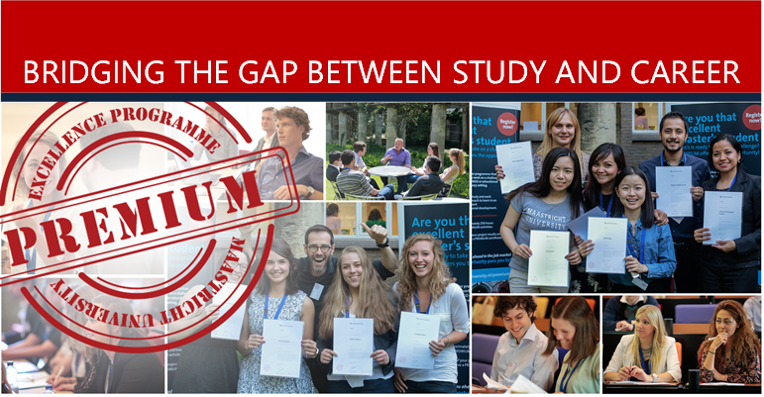

Chapter 1: Important Programme Information
PREMIUM is Maastricht University’s interdisciplinary Honours programme for high-performing, motivated master’s students. Once selected, students are grouped together in interdisciplinary teams and given an assignment to complete for a client from the (local) business or government sector under the guidance of a project mentor. Alongside their project, students receive individual coaching focused on personal competence development. Lastly, they attend several workshops and masterclasses to help cultivate valuable skills and knowledge to prepare them for the job market.

  - The PREMIUM Student Profile
PREMIUM is a programme for highly motivated, enthusiastic and talented students who wish to work in an interdisciplinary team in addition to their study programme.
- A PREMIUM student is competent and proficient: is highly capable, as evident in:
  - their GPA (a 7,0 Bachelor GPA, or higher, is required);
  - their academic history (e.g. skipping grades, double degrees).

- A PREMIUM student has an intrinsic drive to prosper: goes the extra mile and makes use of opportunities to learn and expand their horizon. This should be evident in:
  - the student’s work/internship/volunteering history;
  - involvement in extracurricular or community activities;
  - an enthusiastic, ambitious, motivated, and curious attitude indicating a clear eagerness to learn;
  - a wide and varied area of (academic) interests.

- A PREMIUM student is a true team player: recognizes the value of teamwork and is serious about partaking in it, as evident in:
  - a reliable, flexible, and dependable work ethic;
  - a social and communicative disposition;
  - an ability to reflect, and provide and receive feedback;
  - evidence of team spirit.

- A PREMIUM student is dedicated: takes their role and tasks seriously and acts accordingly,
as evident in:
  - an overall confident and professional approach and attitude;
  - a preference for adequate, creative, and innovative solutions when faced with a challenge;
  - a critical and conscientious mind-set.
  - Learning objectives
Working on a team assignment for an external client in an interdisciplinary setting will help to prepare students for the labour market. In addition to master classes and workshops, they will receive intensive competence coaching on both their team performance and their core skills and competences.
Specifically, PREMIUM’s learning objectives enable students to:
- gain insight into their strengths and areas for development;
- improve their performance and competences;
- learn how to work as part of a team of different disciplines;
- learn how to work to a tight schedule, and managing a large variety of tasks;
- learn how to manage a client’s expectations.
In addition, PREMIUM provides students with advice and tips on how to succeed in the job market.
1.3 Student Time investment PREMIUM

PREMIUM is a demanding extracurricular programme. This means that participating in PREMIUM will require students to invest time alongside the time they invest in their master’s programme. Dedication and commitment are required to succeed in PREMIUM. Over the course of the five months of PREMIUM, the total workload is approximately 250 hours. This is broken down into:
- 150 hours for the project;
- 60 hours coaching and the student’s Personal Development Plan;
- 15 hours for workshops and masterclasses;
- 25 hours for attending Central Events.

Upon successful completion of the programme, they will receive a PREMIUM certificate.
1.4 Mandatory character of the programme

Participating in PREMIUM is not without obligation. Whereas students are entirely free to plan team meetings when they best suit them and their teammates, there are several programme components that require their mandatory attendance. Some of these programme components are more flexible than others are.
For example, students are required to attend a minimum of 6 workshops. These workshops are offered several times on different dates and times to ensure that every student is likely able to attend at least one of the options. Their attendance is also mandatory at the PREMIUM Central Events. These events are organized on set dates.

1.4.1 Exceptional circumstances
Students are expected to always be able to schedule their meetings with the coach or mentor.
In case a student is unable to 1) attend the required number of workshops, or 2) attend a Central Event due to a serious personal situation or highly important prior engagement, they may make up for missing a workshop by submitting a substitute assignment. In that case, the student’s attendance requirement is fulfilled if they attended 5 workshops and submitted 1 substitute assignment evaluated as satisfactory.

Students should email the PREMIUM Central Management Team in case exceptional circumstances apply. Upon evaluation of their request, they may receive a substitute assignment.
Timeliness: in any case, students are advised to contact the PREMIUM Central Management Team whenever private, personal circumstances (threaten to) get in the way of their participation in PREMIUM. We understand life can throw a roadblock and we are always willing to look for a solution together if a student informs us in a timely manner.

1.5 Address issues timely
When students encounter challenges with their client, Mentor, Coach, or team that they cannot resolve on their own, it is crucial to address these issues in a timely manner. The same goes for when you as Mentor or Coach feel you run into issues you cannot overcome. While self-reliance is key (this is also part of the learning experience), and not every minor issue needs to be escalated, it is important not to let problems go unaddressed for too long. The PREMIUM Central Management Team (PCMT) are here to assist when situations become unmanageable or begin to affect your progress, development and experience negatively. By reaching out early, rather than waiting until the issue becomes critical, the PCMT can intervene, mediate, and help get things back on track, preventing situations that could have been resolved from escalating to a point where they can no longer be turned around.

1.6 Assessment
Assessment occurs based on:
- The Project Mentor’s evaluation of the students and the team (both procedural as in individual performance as a team player and the quality of the end product);
- The Coach’s evaluation of the time and effort put into the coaching component of PREMIUM;
- A set of formal requirements, assessed by the PREMIUM Central Management team.

Please note that your specific role in the assessment process will be explained more clearly when the time comes to assess the students. In case you see a student going off track, we expect you to inform PREMIUM Central Management Team a.s.a.p., so that a performance improvement plan can be put into place.

After fulfilling all mandatory programme components successfully, students will receive an official PREMIUM certificate. This certificate is proof of their excellent capabilities at Maastricht University. The certificate will be awarded to them at the certificate ceremony at the Closing Event in May.

1.6.1 Assessment criteria
In order to successfully complete PREMIUM and receive their certificate, students must fulfil the following requirements. Please note that the assessment of some of these requirements lies entirely with the project mentor or competence coach.
The student or the student team:
- Student: attended 3 mandatory workshops and at least 3 of the elective workshops.
- Student: attended at least 2 out of 3 Central Events: the Mix & Match, Midterm Presentations, and Closing Event;
- Student: attended at least three separate coaching sessions, (taking place preferably before set deadlines), as confirmed by the coach and has shown a genuine effort in (further) developing themselves personally and professionally;
- Student: completed a Personal Development Plan together with and graded as satisfactory by their coach;
- Student team: presented their project progress during the Midterm Presentations event, and a video during the Closing Event;
- Student team: documented their project progress by means of an Instagram page;
- Student team: submitted (a representation of) the final product/deliverable or end result to PREMIUM and the project mentor;
- Overall, the student received a positive evaluation from 1) the project mentor, 2) the competence coach, and 3) their team mates.

1.7 Responsibly using AI during PREMIUM
At PREMIUM, we recognise the potential of generative Artificial Intelligence (AI) models. These models provide opportunities that, if harnessed correctly, can energise education. As we learn how to integrate generative AI models into our teaching and learning, we need to make sure we stay within the law and act ethically. We have provided our students with the following guidelines to take into account when using AI models during PREMIUM:
- Use generative AI as supportive learning tool: AI can be a tool to enhance, not replace, the diversity of other common learning approaches. Do not only rely on AI tools; maintain a balance and use them as aids rather than replacements for critical thinking and academic writing.
- Consider potential biases and/or flaws: AI models generate texts that reflect their training data, which might be skewed and/or biased. Realise that answers generated by AI-models might not be reliable. Always make sure to double-check AI output, using other sources (such as scientific articles) to critically evaluate results.
- Acknowledge and cite the use of generative AI in academic work: when using AI Tools to generate content or insights for your assignments, make sure that you properly cite the tools or algorithms employed, following generally accepted citation guidelines.
- Anonymise data: always make sure to anonymise information you share with a generative AI model. This includes information relating to you, your peers, and other third parties that you interact with in the context of projects.
- Take into account Intellectual Property laws: it is your responsibility to ensure that your input and the AI’s output are in alignment with the law (e.g. think of copy-, licensing-, and publicity- rights). If you share output that you generated using AI, be aware that you are accountable for it.
- Familiarise yourself with criticisms on AI usage: we encourage you to discuss the societal and environmental impact AI (potentially) has, together with peers and staff members. Consider for instance that fair access to AI tools is crucial for its positive societal impact. Moreover, be mindful of the large energy demands of data centres that support AI technologies.

Chapter 2: Central Events
Over the course of the programme, PREMIUM organizes several central activities for all PREMIUM students, mentors, coaches, and clients. All events contain educational and/or assessment elements and offer opportunities for students, UM employees, and clients to meet, connect and network. At all central events, attendance is mandatory for all students. The attendance of Coaches and Mentors is highly appreciated.
!! A photographer will take pictures during most of our events. These pictures will be used for promotional purposes. In case you do not wish us to use your picture, please send an email to premium@maastrichtuniversity.nl.

2.1 The Mix & Match Kick-Off Event
The PREMIUM programme is officially opened with a festive kick off opening event: “the Mix & Match”.
After getting through the PREMIUM selection procedure, we want to officially welcome our students to PREMIUM, and kick-off the programme together with a bang!
Additionally, the Mix & Match is a networking event aimed at guiding team formation. By the end of this event, we receive the students’ and the clients’ team preferences, after which Central Management will form the final project teams. At the event, students will get an opportunity to first meet and get to know each other.
We also invite the Project Mentors and Coaches to this event. For the Mentors, this is a unique first opportunity to meet their client, and assist in the team formation. For Coaches, it is also an opportunity to meet the Mentor and client, and encourage and support students during this networking event.
The PREMIUM Mix & Match Event will take place
on Wednesday January 7th, 17:00-22:30 hrs
(Please check your email for further instructions and the exact itinerary)

2.2 Midterm Presentations
Halfway during the programme, each PREMIUM student project team will have to pitch their project and progress, during the PREMIUM Midterm Presentations event.
Pitch & Sinek’s Golden Circle
A pitch is a quick and well-designed speech designed to sell a product, idea or yourself, in a very short time frame. It is designed as an answer to one essential question: why is your team spending their time on this project? Or in your future career: why are you spending time to apply for this job and why should you be considered as a candidate?
Pitching is a tool organizations use more and more as part of their recruitment and selection procedures. Even your motivational letter can be perceived as a personal pitch. Even more reason we feel it is important to provide our students with some practical pitching experience in PREMIUM.
During the PREMIUM Midterm Presentation, we therefore request that each team gives a 5-minute pitch about their project progress and outcome thus far/up to the moment of the Midterm Presentations. They will do so, structured and based on Sinek’s Golden Circle.
Why — Your project’s PURPOSE: The “why” is the core motivation, vision, or “itch to scratch” for doing your project. It is the vision that motivates the entire project. It is the core upon which strategies are built.
How —Your project’s PROCESS: The “how” describes the things that you want to accomplish to achieve the “why”, any specific actions you have taken as a team during your project.
What — your project’s RESULT (so far): What do you do? The things you do to implement your strategy for your project: plan, goals, and tactics.

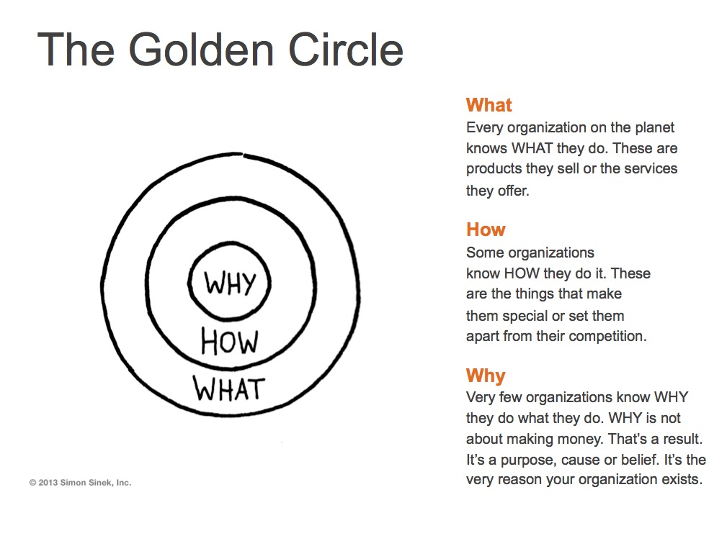

Programme of the evening
Each team has 5 minutes to pitch their project progress. After each pitch, time is scheduled for one team to give positive feedback, after which a second team will provide a point for improvement in a constructive manner, after which a third and final team will be invited to ask an in-depth question concerning the project.
The total time for each team comes out of approximately 15 minutes. Teams will present in rounds of 4-5 consecutive presentations, with a 30-minute break in between the rounds, during which drinks and snacks will be provided. At the end of the evening, we will have an informal get together to exchange experiences and socially interact.
Two Midterm Presentation evenings are organized, as there are too many teams to plan all in one evening. A schedule will be drawn up for each team when to do their presentation, and to give feedback or ask questions. You are only required to attend the evening your team is scheduled to deliver their pitch, although you are more than welcome to join the other evening too.
Assessment criteria for the Midterm Presentations Pitch
  - Your PowerPoint presentation is structured according to Sinek’s Golden Circle, and clearly indicates the WHY, WHAT and HOW of your project.
  - One member of the student team emails their PowerPoint file to premium@maastrichtuniversity.nl, before the deadline Monday March 16, 09:00 hrs.
  - The pitch has a duration of max. 5 minutes, no more, no less.
  - You can use picture, images, entire posts or screen shots. Feel free to be as creative as you want to. As long as it helps getting your message across and is relevant to the story.
The PREMIUM Midterm Presentations sessions will take place
on March 18th and March 19th, after 17:00 hrs.
(Please check your email for further instructions and the exact itinerary)

2.3 The PREMIUM Closing Event

The PREMIUM programme ends with a very festive Closing Event for all students, Project Mentors, Coaches, and clients. This festive Closing Event aims to provide students with an opportunity to share their projects’ results with the community, and to festively close PREMIUM.
Finally, all students who have met the programme requirements receive their PREMIUM certificate and the day is concluded in a festive manner with drinks, food, and entertainment.

PREMIUM Video Pitches
During the PREMIUM Closing Event, each student team needs to translate their project process and outcome into a 2-minute video pitch, to play during the PREMIUM Closing Event. Hereby aiming at teaching our students how to present their results to non-expert audiences and peers, but also providing them with the opportunity of seeing everyone’s results highlighted.
We are using video pitches as tool to present the project outcome, because videos are being used more and more to pitch new products to clients or customers in the world of consultancy. Since our students have been functioning as consultants to their PREMIUM clients, it is only fitting that they wrap up their project as such.
To facilitate this, we will host rounds of video presentations. After every video, there is time for the audience to ask questions to the team showcasing their project results by means of the video.
A jury will also be amongst the guests, asking questions, and a special prize will be awarded to the team whose video shows that they have used PREMIUM the most to go the extra mile in their project.
Please note that we also expect our students to schedule a closing session with their client, mentor (and coach) to present the final deliverable to the client and discuss the process of the project.
Criteria for the video:
- Your video should not be longer than max. 2 minutes.
- The format of the video includes again the concept of Sinek’s Golden Circle (the WHY, WHAT and HOW of your project).
- Make sure you explicitly touch upon the impact your project made, or its relevance to the client.
- We recommend you add closed captioning to your video, and check that the volume of all speakers is high enough.
- Suggestion: think about answering these questions:
  - Someone says, “So, tell me about your project.” What do you say? What would you tell them about your project in 2 minutes?
  - What was your outcome and how did you achieve it?
  - What have you learnt from working on the project with your team?
  - What challenges did you overcome, what successes did you celebrate?
- One member of the student team emails the digital file of the video to premium@maastrichtuniversity.nl and the Project Mentor, before the deadline
(Tuesday May 26th, 09:00hrs)
General guidelines and tips for the video:
- PREMIUM can give you access to Powtoon. If you would like that, please send a message to premium@maastrichtuniversity.nl.
- Voice over is possible, but not required if your video is self-explanatory.
- Be mindful of copyrighted music or sound effects.
- Hook the viewer. Viewer attention is very limited. In this case, the audience will have to watch between 15-20 videos, and you want them to be on the edge of their seats for those 2 minutes that your video is showing.
- The structure of the video is important, remember to have a start, middle and end to your pitch and take your audience on a journey if you can. A great narrative structure will reinforce your message and leave the audience with a sense they really understand what your project was about and what you have accomplished.
- Surprise with creativity, your audience will watch many pitch videos and you want them to remember you. Being structured with your messaging does not have to mean you cannot be creative in the way you deliver the information. Adding elements of surprise, delight or creativity will make your pitch stand out from the rest.
- Avoid using jargon, acronyms, or unusual abbreviations.
PREMIUM Instagram Award
During the PREMIUM Closing Event, we are also handing out a special prize to the student team that has put most effort in their Instagram page.
The PREMIUM Central Management will select 3 nominees, after which the entire community will be asked to vote during the Closing Event for the team YOU believe has the best Instagram page.
When selecting the nominees, we take into consideration the following aspects: usage of creative skills, consistency, show of teamwork, ability to get the message across.
The PREMIUM Closing Event will take place
on May 28th, after 14:00 hrs.
(Please check your email for further instructions and the exact itinerary)

Chapter 3: The role of the Client and Project outcome
3.1 The Client
The role of the client is to provide the objective for the project. In a way, the student team acts as independent consultants to the client´s company or organization.
The client has a big impact on the success of the project, and they determine the relevance of the project and ensures that the project contributes to the goals of the organization.

Make sure you know who exactly your client is, and that this role is taken on by one, or at most by two persons. You will need this person’s personal commitment throughout the project. The decision who the actual client (not an entity or organization, but a person) is, and what level of authority they have, must be known before the project can successfully start. PREMIUM does its best to ensure that every project has a single, and a sufficiently authorized client, but things might change within organizations between the time of agreeing on the project proposal and the actual execution of the project, and even the finalization of the project. Therefore, always make sure you know whom your client is.

The actual role your client will take depends largely on their preference. Generally, a client either acts more as a formal client or as a co/creator.
- A formal client provides an assignment and perceives the student team as consultants doing a job for them. The formal client provides guidance and supports the team with feedback, but is not actively involved in project execution.
- A co-creator might join the team for brainstorm sessions, meetings, and preparatory sessions. The co-creator is more actively involved in and during the project execution. Both approaches have their own set of merits and relative shortcomings, but often one or the other suits the project or the client better. Either way, the contact you will have with the client should be on a highly professional level only.
Since the client is mainly interested in getting the best possible outcome of the project, it is vital that the project mentor functions as an intermediate between client and students at times. Specifically when decisions need to be made, or negotiations need to be done, with regard to the project scope and the project outcome.

Non-Disclosure Agreement (NDA)
In order to safeguard the company information that you will receive from the PREMIUM clients, we will provide clients with the option to make use of a non-disclosure agreement. This legal contract between the UM, the PREMIUM students and the company, outlines that the confidential material, knowledge, or specific information that is shared, will not be published in any of the reports or final products. This NDA will create a confidential relationship between the students and the client, and will make sure that everybody involved is aware of the restricted use of a specific part of the information provided by the companies. The document will be provided upon request by the PREMIUM Central Management Team.

3.2 The final product and end results
Finishing the project should produce various types of outcomes. Outcomes may include a final report, a final product, or a concrete plan for future development. Due to the variety of projects in PREMIUM, no generic guidelines are given for the final product/result of the project. This will be done in close interaction between the Mentor, the client, and the team itself. In an early stage of the project, you will have to define the criteria, scope and the type of the final product/result together.

3.3 Project Budget

Project execution might require your team to spend some money. The team might benefit from a teambuilding activity, or perhaps project execution requires them to purchase specific materials, or pay for a service.

All PREMIUM teams can be reimbursed by EDLAB, for up to a maximum of € 150 project-related costs after the programme (transportation costs not included). We request that the mentor keeps an eye on these costs, and sees that the budget is spent sensibly and just. Not solely on cocktails etc. for example.
3.3.1 Reimbursement of Travelling Costs
Should a client request students and/or Project Mentor to travel, they are requested to take charge of these costs and reimburse you. You need to know that your client has agreed to this when they submitted their project to PREMIUM. It is therefore important that your client agrees to your budget as well, where transportation costs are involved.
Once your client has approved to the proposed budget for transportation, you will need to make clear agreements with your client on how they will reimburse you, and keep PREMIUM informed about this:
Option 1 (PREFERRED): Your client reimburses you directly. Every organization has their individual way of arranging declarations of expenses, so make sure your client informs you how to go about this. PREMIUM will not be a part in this process.
Option 2: You declare your transportation costs by means of a UM declaration form “business trip” to PREMIUM, and include all your original train or bus tickets, or declare kilometres by car at Euro 0,23 p/km. PREMIUM will then send an invoice to your client for these costs. Your client however will need to inform you what the invoice details (name, address, email address, order number) ought to be, and you will need to let PREMIUM know.

Chapter 4: The role of the Team, Project Mentor and Coach
During PREMIUM, our students will work closely together not just with their team members or client, but also with their assigned Project Mentor and Coach. Their roles, responsibility and type of support are quite different, but at moments also overlap. Below we will discuss what these differences in roles and responsibilities are.
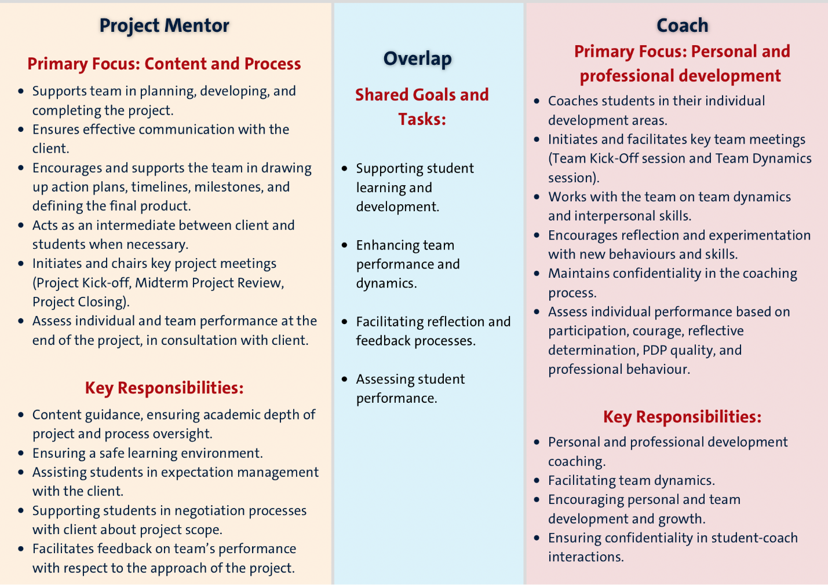

4.1. The role of the Project Mentor
Throughout PREMIUM, the Project Mentor will support the team in planning, developing, communicating with the client, and completing the assignment. The Project Mentor is responsible for the content part of the project and the process, whilst the Coach is responsible for the team dynamics and the (inter)personal skills of the students.

- In order to guarantee a safe learning environment and (often) a first experience for students in tackling interdisciplinary project based working for a professional client, the main concern of the PREMIUM Project Mentor should be the student’s learning experience, whereas the client’s main concern and interest lies with the project.
- The team will decide on group leadership. Together with the group leader, the Project Mentor takes the role of steering and guiding the group to the agreed upon assignment. Please note that the Project Mentor should not take over the role of the project leader in the team, since the learning experience for the team would then be less effective.
- The team is not only responsible for finishing the project on time and meeting the expectations of both the client and Project Mentor, but also for delivering the required results. The Project Mentor however, helps the team draw up an action plan, set a timeline, milestones and define the final product.
- The Project Mentor can and should function as an intermediate between client and students when the scope of the project requires re-definition and can provide support to the students in negotiation processes with the client.
- PREMIUM is first and foremost a learning experience for the students. The client offers the students a learning environment to experiment with new behaviour. The Project Mentor assists the students in their communication with the client (expectation management) and, at the end of the project, asks the client for feedback on the team performance.
- The Project Mentor also initiates and chairs the Project Kick-Off meeting and Midterm Project Review meeting, as well as the closing meeting at the end of the programme.

Due to the variety of projects, no generic guidelines are given for the final product/result of the assignment. This will be done in close interaction between the Mentor, the client, and the team itself. In an early stage of the project, you will have to define the criteria, scope and the type of the final product/result together.
At the end of PREMIUM the Project Mentor will grade and assess individual and team performance based on at least the following and more criteria:
- Participation (effort, time and energy put into project execution and teamwork);
- Courage to experiment with new ideas and behaviour;
- Reflective determination to improve the team process;
- Professional behaviour.

Tip!! Contact the Coach(es) of your team on a regular basis to align the process with the interventions (if needed).

4.2. The role of the Coach

Your responsibility as a Coach lies in coaching your students during the PREMIUM project, to help identify a competency they like to work on, to invite them to reflect on their behaviour and to invite and encourage them to experiment with new behaviour, attributes, skills, and knowledge. This process between student and Coach is strictly confidential and you are kindly asked to make this explicit in the first meeting.
Finally, you are expected to give an overall evaluation of your findings with regard to the students’ process to the student in the last meeting.

At the end of PREMIUM, the Coach will grade and assess the individual performance of each student in the coaching process based on at least the following and more criteria:
- participation (effort, time and energy put into coaching);
- courage to experiment with new ideas and behaviour;
- reflective determination to grow and expand self-knowledge;
- the quality of student’s PDP;
- professional behaviour.

4.2.1 Individual Coaching meetings
Over the course of PREMIUM, you will meet with your students on several occasions. Whether or not you meet physically or virtually with your students, is up to you and their preference.
You will plan 3 individual meetings with each assigned student. These meetings are to take place spread out over the course of the programme and thus before set deadlines. In the 1-hour long individual sessions with your student, you will discuss performance and development goals. There are different prescribed topics for each meeting, but as coaching can be very dynamic the exact content of your meetings might slightly vary in practice.
- Meeting 1 (to take place before Friday February 27th): In this meeting, you will discuss your working relationship, the topic(s) your student wishes to address during coaching, and goals concerning their development. The basis of the meeting will be the components of the PDP the student completed before the meeting.
- Meeting 2 (to take place before Friday April 17th): in this meeting you will discuss the progress with your student.
- Meeting 3: (to take place before Wednesday May 20th): your last meeting will be used to reflect on your student’s personal and professional development during PREMIUM.
4.2.2 The Personal Development Plan (PDP)
Over the course of the programme, students will complete a document chronicling and guiding their professional development under the guidance of their Coach. The PDP will serve as a journal to their development during PREMIUM, as well as the basis for future development undertakings.
A template for this PDP, including all different components, is available to on www.edlab.nl/premium.
Please note that this format is a mere guideline, not every section may apply to your specific student, although the first components are required to get everyone off to a good start of coaching. The PDP is a document for student and Coach’s eyes only! If as a Coach you prefer to use a different format to document your student’s journey, feel free to do so.
4.2.3. A PREMIUM Coach’s attitude
Your coaching role begins with your basic attitude; the attitude you have when you are working as a Coach. No matter how you are going to coach – what methods and techniques you are going to apply – effective Coaches always have a certain basic attitude. What do you need in order to be an effective coach?
- Attention: pay attention and be there
This is one of the main requirements for having a successful coaching meeting: you have to pay full attention and be there for the other person for the full 100%. ‘Being there’ means you have to clear your head and put your own worries, emotions, uncompleted tasks and conversations you have to hold neatly away in the drawer of your brain; you must only open the drawer of the other person. This also means that you should be in the ‘here and now’: you focus your attention on what is. If you feel you cannot fully be there for the other person, it is best to not have the coaching meeting at all.
- Acceptance without judging
To be there for someone else also means you accept the other person as they are without any judgment. You as Coach may be aware of your own reactions and preconceptions but you will just have to park them and clear your head. Do not judge. Accepting the other person as they are and trying to understand their thinking and emotions is what makes a coaching meeting stand out from daily conversations, because true attention is rare. Your attitude communicates to the other person: ‘I am trying to understand you.’ Acceptance also means you have to accept yourself. You can only give something to someone else if you have it yourself. It is not until you can let go of your own judgments (and your own fear of failure) that you can be there for the other person. Acceptance does not mean that you do not make a judgment about what you hear, nor does it mean that you do not have an opinion of your own or that you do not interpret it in your own way. You must however be aware of the fact that the only important thing is the meaning the other person gives it.
- Association with the story of the other person
A Coach needs to accept the other person as they are in order to be able to associate or identify with the subjective experience and way of thinking of the other person. Only then will a Coach be able to do identify with them. Someone who has only just started coaching others often asks many questions at the beginning of the meeting, which turns the meeting into an interrogation and forces the student to follow you rather than the other way around. Following the other person in their story gives them the chance to tell their story in their own way, which will provide you with more information. It will also give you more time to observe their body language. Please note: Stopping the student if you no longer see the connection or if you feel that they are talking about distracting details is also a form of association (!)
- Authenticity, realness
Act as yourself, be yourself (there are plenty of others). Be aware of your own qualities, pitfalls and learning objectives. Do not play a role because you will not be able to keep that up. Know and acknowledge your own limitations. For example: ‘I notice you continuously give evasive answers and I feel I'm getting annoyed by this.’ And you don't have to know everything. A coach does not need to have answers readily available, because a coach helps the other person with finding their answers.
4.3. The Student Team
“Teamwork makes the dream work.”
In PREMIUM, our students spend the majority of their time working on their project on a team basis. Not only does teamwork allow for brainstorming creative solutions much better than working by yourself ever will, but working in a team (especially an interdisciplinary and multicultural one) also means that together you surely have enough time, resources, and mental capacity to get the job done right. As Aristotle famously claimed: “the whole is greater than the sum of its parts”.
Even though teamwork generally is a very rewarding experience, it can also be challenging at times. Especially in a situation with limited time, added pressure of working with an external client and different disciplines/academic backgrounds. This is all part of the learning experience, which PREMIUM first and foremost is. The good news is that there is a solution for everything and since it is a learning experience, Central Management will try to support you in any way possible.
4.3.1 Peer Feedback “Watering Flowers” and “Reflections for the Future”
The art of giving and receiving feedback can be a difficult one to muster. Students, and even our most experienced Coaches, Mentors and even clients, may find it triggering or confrontational, but giving and receiving feedback is an essential element for development and growth. Therefore, in PREMIUM, we encourage the use of positive and supportive language to foster a constructive environment, based on a growth mind-set, where our students can practice giving and receiving feedback.
We do so via the "Watering Flowers" principle, which is a metaphor used to emphasize nurturing and growing one's strengths and potential. It is about providing the right kind of support and feedback to help someone grow. Instead of focusing on mistakes or weaknesses, it emphasizes recognizing and encouraging positive traits and behaviours.
Applying this principle as a tool for feedback has certain benefits:
- By focusing on strengths and potential, this approach helps build self-esteem and confidence. People are more likely to take risks and try new things when they feel supported and encouraged.
- It fosters a mind-set of continuous improvement and growth. People are more motivated to develop their skills and abilities when they receive positive reinforcement.
- Encouraging and supporting each other strengthens relationships and creates a positive environment where everyone feels valued and respected.
- When people feel good about their abilities and are motivated to improve, their overall performance improves. This leads to better outcomes in both personal and professional contexts.
During PREMIUM, students will be required to provide their peers with open and constructive feedback on two occasions. Once halfway through the programme, and once at the end of the programme. Only the midterm peer feedback is used and discussed in a team setting. See the instructions below.
Peer feedback may reveal participation and collaboration issues, but also personal achievements of individual group members, which the Coach and Project Mentor might otherwise not know about. It can also provide a starting point for constructive discussions and reflections on how the group is functioning in general, and how every individual is contributing to and benefitting from the team process. This system of peer feedback encourages thus as well teamwork, positive interdependence, and individual accountability, whilst giving the Coach and Project Mentor an insight into the individual performance and development of each individual team member.

Instructions Midterm Peer Feedback “Watering Flowers”:
- Each student fills out a form “Watering Flowers” for every member of their team.
- Each student fills out one self-assessment form on their own performance.
- Each student sends all forms to both the Coach and Project Mentor, at least 48 hours prior to the Team Dynamics Session with the Coach.
  - The Coach will discuss the generally provided feedback, patterns they notice based on the provided feedback, or luring conflicts, during the Team Dynamics session in a safe environment. During the Team Dynamics Session, the Coach uses the provided midterm peer feedback as a basis to open up a conversation about team dynamics, underlying issues, individual performance and development, but by no means should the feedback from one student be sent to another student without prior consent or guidance. It will compromise the confidential nature of the feedback.
  - The Project Mentor may address general observations in their meetings with the team, but by no means should the feedback from one student be sent to another student without prior consent or guidance. It will compromise the confidential nature of the feedback.

Instructions Final Peer Feedback “Reflections for the Future”:
- NOTE: this is just for the Coach and Project Mentor to know what is requested of the students, though no action from you is required.
- Each student fills out a form “Reflections for the Future” for every member of their PREMIUM team (or write it in an email, or any other creative format they want to use).
- Each student sends each of their team members their form before the deadline of Thursday 21.05.2026.
- The goal is to reflect on what their teammate did well, where they can grow, what was learned from them, and to leave them with a warm wish for the future.
- This form is peer-to-peer only and will remain private between each individual student and their team member.
- Students may also choose to share their peer feedback with their Coach and/or Mentor, but this requires consent from both the giver and the receiver of the final peer feedback.

4.3.2. Project-related team tasks
Throughout the PREMIUM programme, students will complete various tasks that we expect either Mentor or Coaches to assess in or at least be aware of.
- Students are required to set up a preliminary budget describing the costs they expect to make throughout the project at the beginning of PREMIUM. The Project Mentor (and client in case of traveling costs) is/are meant to sign off on that budget.
- Students have to prepare a pitch style presentation for the Midterm Presentation session.
- Students maintain an Instagram page to document their project progress. This is a platform for the Mentor (and Coach) to monitor as well in order to stay updated on a regular basis.
- Students prepare a video pitch to present their project outcome during the PREMIUM Closing Event.
- Students send in a finalized budget and reimbursement forms if they made any project-related costs. Mentors should assist students in the reimbursement application process.

Chapter 5: Structure of set meetings throughout the programme
As a Project Mentor and Coach, you will be required to schedule certain fixed meetings with your students. Below you can find a visual representation of how these meetings relate back to either the project and its content, the team and the process, or the individual self-development of a student.
Both the roles and content of certain meetings of the Project Mentor and Coach will at times overlap. Therefore, we find it very important, that the Project Mentor and Coach remain in close contact with each other.
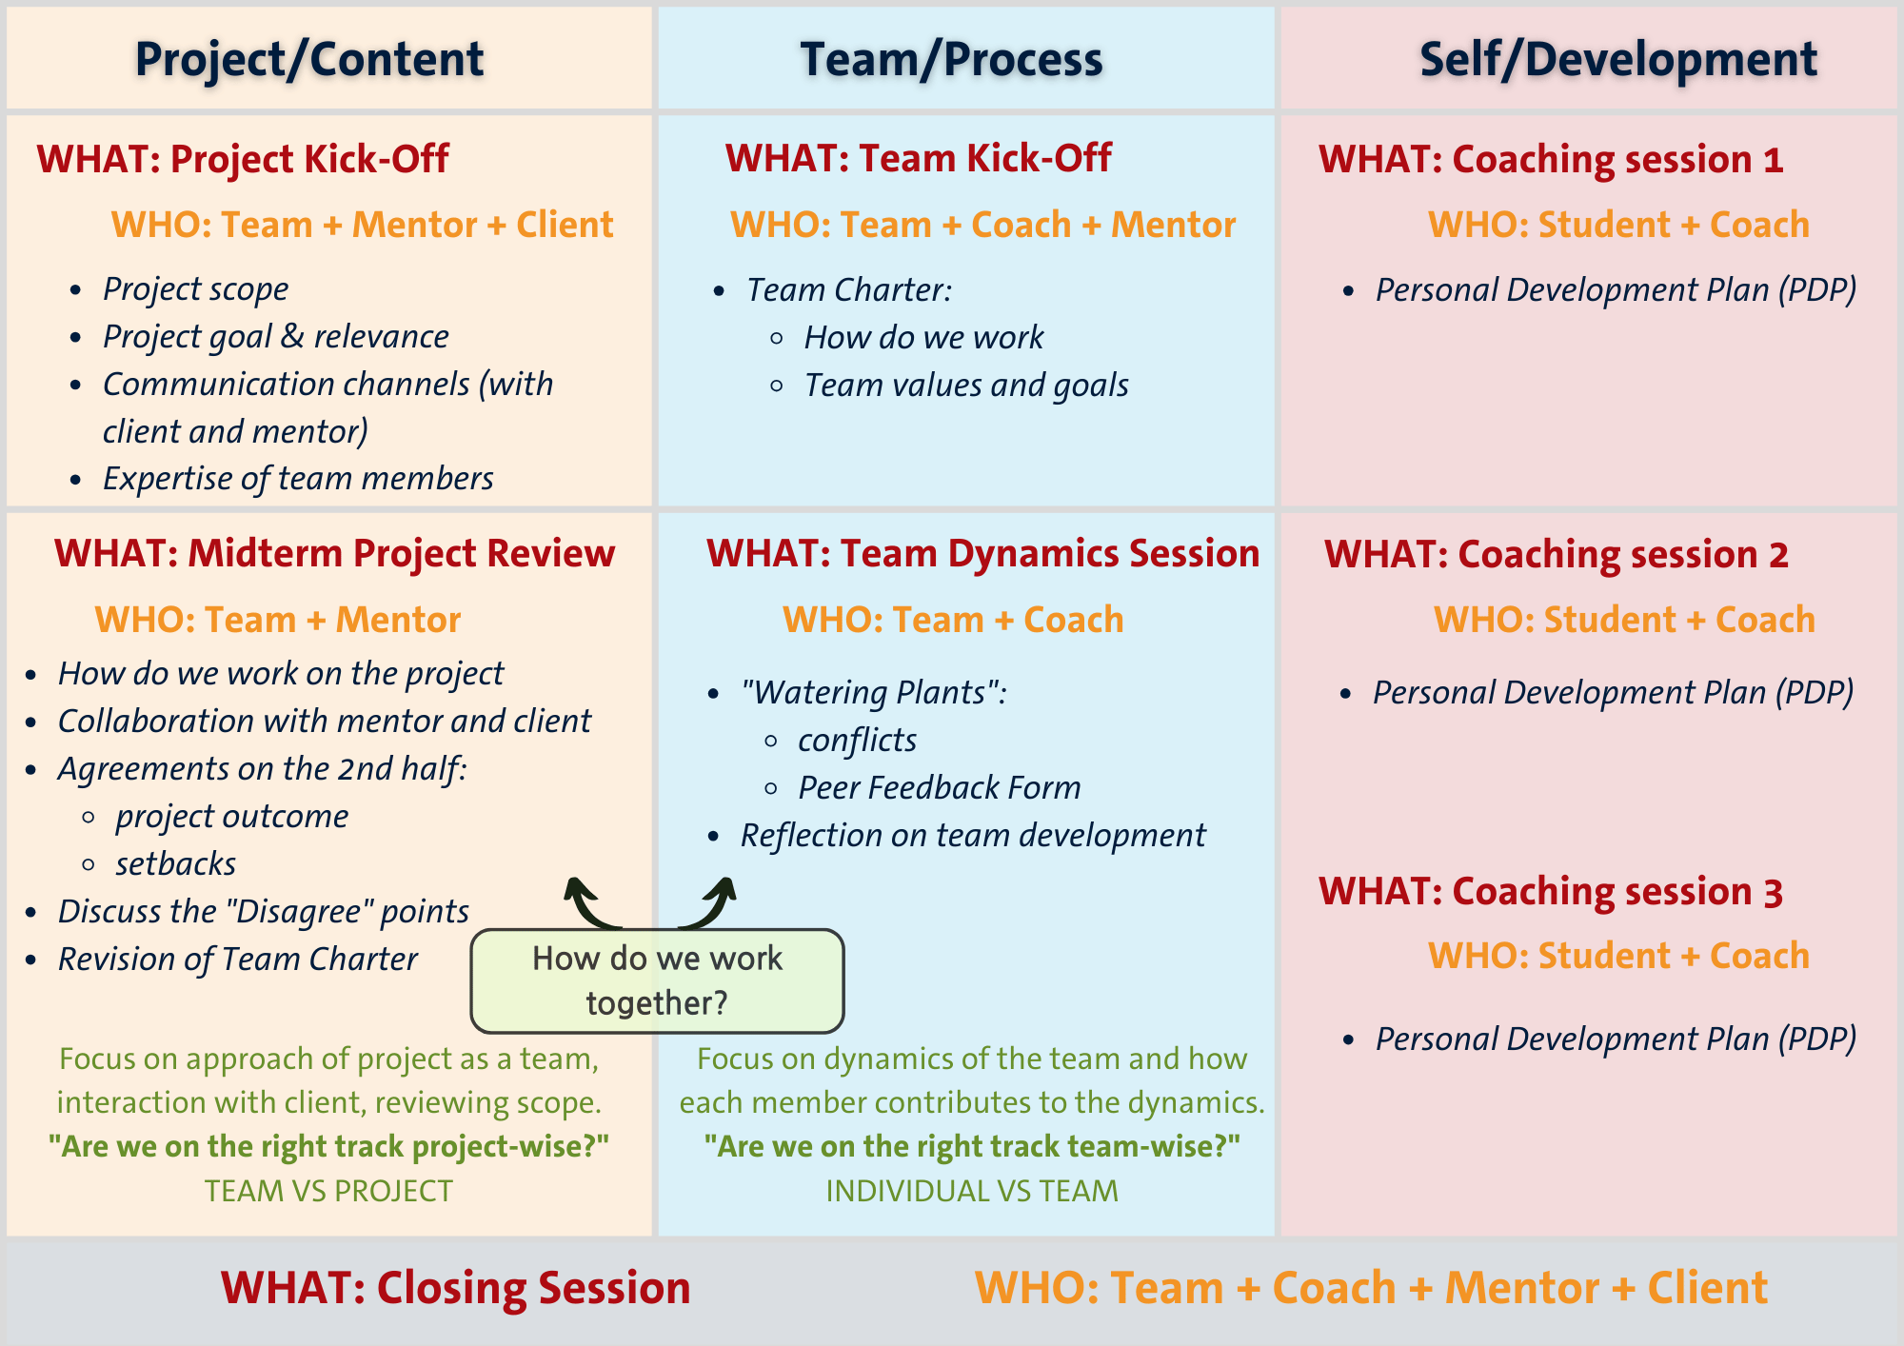

5.1. Kicking off the project and team journey
Once the PREMIUM teams are formed, the actual journey is about to begin; time to start working on the PREMIUM project. We kick off this journey, with two different sessions initiated by the Project Mentor and the Coach: The “Project Kick-Off” and the “Team Kick-Off”.
Each session serves a distinct purpose and focuses on different aspects critical to the project's success. Both sessions are crucial for the success of any project.
- The Project Kick-Off (initiated by the Mentor) ensures that the team has a clear roadmap, while the
- Team Kick-Off (initiated by the Coach) ensures that the team is equipped to work together effectively to follow that roadmap.
By understanding and participating fully in both sessions, students will be better prepared to tackle their project with clarity and cohesion, maximizing their chances of success.

5.1.1 Project Kick-Off Session, initiated by Project Mentor
The Project Kick-Off session (deadline: Friday February 6th) is a collaborative meeting where the project team, along with the client and Project Mentor, come together to discuss the project's foundational elements.
This session is primarily focused on the content and objectives of the project.
The Project Mentor will initiate this meeting, inviting the client and the students.
The primary outcome of the Project Kick-Off session is a shared understanding of what the project entails, what the goals are, and how the team will leverage its collective expertise to achieve them. This session ensures that everyone is aligned on the project’s objectives and expectations.
The Project Kick-Off meeting plays a crucial role in ensuring project success. It establishes clear project goals and scope, aligns team members and clients on expectations, facilitates effective planning of timelines and resources, and identifies potential risks early on. By providing a solid foundation and shared understanding, the Project Kick-Off is the starting point for coordinated efforts and successful project outcomes.
Key activities during this session include:
- Identifying and exploring the core issue: A first interaction with the client to understand the fundamental problem driving the project. A critical discussion helps ensure that the team does not base their project on assumptions, but instead, works towards a solution that addresses the actual problem.
- Defining the project scope: Discuss the project boundaries and proposed deliverables.
- Setting goals: Establishing clear, actionable goals that align with the client’s needs and the project's objectives.
- Exploring relevance: Discussing the significance of the project in a broader context, such as its impact on the client’s business.
- Assessing team expertise: Identifying the skills and expertise that each team member brings to the project, ensuring that the team can meet the project’s demands or that the scope of the projects needs to be tailored to the expertise involved.
Form “Project Scope, Success Criteria and Timeline:
After your first meeting with your students and client, your team can fill out the form “Project Scope, Success Criteria and Timeline” (Deadline: Friday February 13th), which will help you, your client and your PREMIUM team in this stage of project development to reach a better understanding and definition of project and key milestones and deliverables. It is not uncommon that you may need to revisit the form and timeline during PREMIUM, but it is important that together with your client and students, you clearly agree on the expectations, boundaries and limits of your project.

5.1.2. Team Kick-Off Session, Initiated by Coach
The Team Kick-Off session (deadline: Friday February 6th), is focused on how the team will work together to achieve the project goals, and emphasizes the process and dynamics of team collaboration. The Coach will initiate this meeting, inviting the Project Mentor and the students.
As a PREMIUM Coach, your role is not just to coach our students individually during their individual process of learning, but also to facilitate the development of a strong, cohesive team culture that is essential for the success of their PREMIUM projects. During PREMIUM, students often work for the very first time on such complex, real-world projects that require a high level of collaboration, creativity, and communication. On top of that, they have to learn how to collaborate with team members with different skillsets, working –and communication styles, and expertise than what they are used to.
Ultimately, the success of their PREMIUM project and overall experience depends on the ability of the team to work together harmoniously and efficiently. Fostering a culture of trust, collaboration and mutual respect are essential to mitigating these risks and ensuring the project’s success.
To facilitate this, students will start their PREMIUM team’s journey with a session facilitated by the Coach (and Project Mentor) to guide them through establishing a strong team culture right from the start. Ideally, the Project Mentor should be present, and we highly encourage close(r) interaction between the Coach and the Project Mentor during PREMIUM.
This Team Kick-Off aims to achieve the following:
- Develop mutual understanding: Help students gain insights into their each other’s values, team roles, and working styles, fostering a sense of unity and mutual respect.
- Promote psychological safety: Create an environment where students feel safe to share their thoughts and ideas without fear of judgment or criticism.
- Clarify roles and responsibilities: Define clear roles for each team member to ensure that everyone knows their responsibilities and how they contribute to the team’s success.
- Establish effective communication: Develop communication practices that facilitate open, honest, and respectful dialogue within the team.
- Create a team charter: Guide the team in developing a team charter that outlines their goals, roles, norms, and commitments to maintaining a positive team culture.
Example of outline for Team Kick-Off Session
Below you can find an example of how such a session could be facilitated by the Coach (and the Project Mentor). Feel free to adapt this outline where you feel it is needed. Find inspiration for icebreaker activities here: https://www.icebreakerspot.com/activities/
5 min. | Welcome  Briefly introduce the session's objectives and agenda and explain the concept of psychological safety, why it is important, and how it will be a guiding principle throughout the session.
15 min. | Icebreaker activity  Example I “Personal Timeline”:  Each student draws a simple timeline on a piece of paper, marking 3-5 significant events in their lives. These could be personal milestones, achievements, or memorable experiences. Students take turns sharing their timelines with the group. This helps students get to know each other on a more personal level while sharing stories they feel comfortable discussing. This activity encourages personal sharing in a structured way that can foster connection without putting too much pressure on any single individual. Encourage students to choose events they feel comfortable sharing. The facilitator can start to set the tone and provide an example.  Example II “Weather Check-in”:  Begin this icebreaker by asking each member of the group to share how they are feeling and what is going on for them right now in the language of weather. For example, I am feeling like its mostly sunny skies with a bit of a rain cloud looming or I feel like I am in the eye of a tornado! Using a metaphor can feel like a safe way to share in a group setting.  Example III “Personal Artifacts:  Each person brings a personal artifact/item and gives it to the facilitator of the session. These items should have a special meaning to the person who brought it. The facilitator puts all the items on a table and one by one, people guess who brought each one. This provides some levity and variety to the meeting- as well as allowing people to gain insight about each other.  Example IV: “5 things I do well”:  Ask people to come up with a list of 5 things they do well. Have a pen and paper at each place setting in advance so that people can brainstorm. Have everyone stand up and share their list with the group.
20 min. | Values and goals alignment  Preparation: Before this session, students need to have filled out the individual part of the Team Charter document, in which they answer a number of questions about themselves and their expectations with respect to the performance of their PREMIUM team. Objective is that everyone shares their individual values and goals with respect to their PREMIUM project, their PREMIUM team and their overall PREMIUM learning experience, so that they understand each team member’s perspective in a supportive environment.  - Facilitate a discussion to identify commonalities and unique contributions within the team while ensuring everyone feels safe to share. Periodically check in with the group to ensure everyone feels comfortable and heard.  - Use a whiteboard or flip chart to map out these commonalities. Create a safe space for students to share openly.
30 min. | Team dynamics exploration  Preparation: Before this session, students need to have filled out the individual part of the Team Charter document, in which they answer a number of questions about themselves and their expectations with respect to the performance of their PREMIUM team.  Facilitator role: Highlight and celebrate each student’s strengths, and normalize discussing areas for growth without fear of judgment.  - Each student writes down their personal strengths and areas for growth on sticky notes.  - Students take turns sharing their strengths and growth areas with the group, explaining how these can contribute to the team.  - Discuss how these strengths can be leveraged and how the team can support each other’s growth areas, emphasizing support and encouragement.
40 min. | Preparation: Download a Team Canvas via the PREMIUM documents page (or see appendix), and project it on a (online) whiteboard or print it on a big enough piece of paper. Bring markers and post-its, one for each participant, different colors.  Facilitator role: Explain the purpose and key components of a team charter, also highlighting the importance of psychological safety. Research on team performance shows that high-quality team charters (written plans for how the team will manage its activities) are positively related to team performance. Drafting a team charter increases team members’ knowledge of the strengths and weaknesses within the team, helps to create shared expectations, and facilitates the establishment of effective group practices for dealing with high and poor performance. A team charter is a strategic framework that helps team members to kick off projects and align on common vision. It is made to smoothly start collective projects, let people learn about each other and accumulate enough momentum to get going.  - Go through each step with the team, making sure to ask the questions for each segment. Encourage people to write their answers on post-its and talk about them with the team. Their individual answers will provide input for these answers.  - Encourage the students to really focus on getting to the point in each section discussion. If some conversations take rather long time or seem to touch upon bigger issues, consider parking those questions, and plan a separate meeting to address them specifically.  - Once the team has agreed on every component, fill out the team component of the charter.  - IMPORTANT: there are no good or wrong answers here. Everyone’s opinion is equally valuable and justified, and necessary to lay the foundation of good team functioning. Encourage the students to be supportive, have an open mind, but also do not be afraid to ask (critical) questions.  - Ensure that the charter includes explicit commitments to maintaining psychological safety, such as “we commit to creating an environment where everyone feels safe to speak up.”
10 min. | Closing  - Summarize the key points covered and the finalized team charter.  - Have each member sign the charter as a symbol of commitment to psychological safety and team collaboration.  - Open the floor for any final questions or comments, ensuring a supportive environment.

5.2. Midterm milestone Meetings
Halfway during PREMIUM, around the time of one of the important milestones for students during PREMIUM; the central event of Midterm Presentations, the Project Mentor and Coach schedule two very important sessions with their student team:
- the “Midterm Project Review” meeting (with the Project Mentor), and the
- “Team Dynamics Session” (with the Coach).
The Team Dynamics session focuses on addressing feedback and resolving any potential dormant conflicts within the team. This session provides a safe space for open discussion, providing each other with constructive feedback, helping team members improve their communication, strengthen their relationships, and foster a positive working environment. By addressing any potential underlying issues, the team can enhance their collaborative practices and work more effectively together in the second half of the project.
The Midterm Project Review Meeting with the Project Mentor serves as a critical checkpoint to evaluate the team’s progress and refine their strategies. This meeting involves assessing the project’s scope, reviewing collaboration with the client, and making clear agreements on how to proceed. By discussing the Midterm Review Form and addressing any concerns, the team ensures that everyone is aligned and that the project remains on track. Establishing clear roles, responsibilities, and timelines for the remainder of the project is essential for maintaining focus and achieving the project goals.
Both sessions are vital for ensuring that the team functions well, both in terms of interpersonal dynamics and project management. They provide opportunities to address issues proactively, enhance collaboration, and ensure the project’s success.
5.2.1. Midterm Project Review Meeting, Initiated by Project Mentor
Halfway during PREMIUM, the Project Mentor schedules a Midterm Project Review Meeting
(scheduled ideally between March 9th and April 17th), which serves as a crucial checkpoint for the team’s progress in PREMIUM.
This meeting aims to make clear agreements on how to proceed in the second half of the project, both content-wise and process-wise.
As a Project Mentor, your role in this meeting is essential in guiding the team towards successful project completion. This session serves as a critical checkpoint to evaluate the team's progress, address any challenges that lie ahead, and refine strategies for the remainder of the project. The focus is on enhancing team collaboration and ensuring alignment with project goals.
The Midterm Project Review meeting is essential for several reasons. Firstly, it provides an opportunity to assess how well the team is working together, fostering a collaborative environment where members can share their experiences and identify areas for improvement. Secondly, it evaluates the effectiveness of the team’s interactions with you and the client, ensuring that communication channels are clear and functional. Finally, it allows for a mid-course correction by addressing any issues highlighted in the Midterm Review Form and updating the team charter as needed.
Students are requested to each fill out a Midterm Review Form (in the appendix or on the PREMIUM website) and submit the filled-out form to the Project Mentor, at least 48 hours before the scheduled meeting.
Example of outline for the Midterm Project Review Meeting
Below you can find an example of how such a session could be facilitated by the Project Mentor. Feel free to adapt this outline where you feel it is needed.
Preparation for the meeting:
- Schedule the Midterm Project Review Meeting with students and mentor present (scheduled ideally between March 9th and April 17th).
- Students are requested to each fill out the Midterm Review Form (in the appendix or on the PREMIUM website) and submit the filled-out form to the Project Mentor, at least 48 hours before the scheduled meeting.
5 min. | Welcome  - Project Mentor welcomes everyone and provides an overview of the meeting’s purpose and outline.  - Briefly revisit the initial project goals and the importance of this Midterm Project Review in ensuring project success. Reiterate the importance of open and constructive feedback throughout the meeting.
45 min. | Discussion on Midterm Review Form statements  - The Project Mentor facilitates a discussion focused on the statements from the Midterm Review Form that had disagreements.  - Each statement is reviewed, with students providing context for their disagreements.  - Group discussion is facilitated by Project Mentor to explore the underlying issues and potential solutions.  - The team reaches a consensus or action plan for addressing the highlighted concerns.
20 min. | Review and update the Team Charter  - Discuss whether the current team charter accurately reflects the team’s values, roles, and collaboration practices.  - Identify any areas of the charter that need revision based on the midterm review discussions.  - Agree on and document any updates or additions to the team charter.
15 min. | Agreement on next steps and action items  - Summarize key decisions made during the meeting and outline the next steps.  - Assign specific action items and deadlines for the upcoming phase of the project.
5.2.2. Team Dynamics Session, Initiated by Coach
Halfway during PREMIUM, the Coach schedules a Team Dynamics Session (scheduled ideally between March 9th and April 17th), which focuses on reflection of roles, addressing feedback and any potential dormant conflicts within the team.
This session provides a safe space for team members to openly discuss their experiences, share and receive constructive feedback from their peers, and identify any underlying issues that may affect team performance. By addressing these concerns, the team can enhance their collaborative practices, improve communication, and foster a positive working environment. The outcomes of this session are critical for ensuring that the team can function effectively and harmoniously during the second half of the project.

Peer Feedback as input for Team Dynamics
Before the session on Team Dynamics, students have been requested to send both the Coach and the Project Mentor their filled-out peer feedback forms (see more info on peer feedback in PREMIUM in paragraph 4.3.1.) and one self-assessment form on their own performance.
These midterm peer feedback forms “Watering Flowers” may reveal participation and collaboration issues, but also personal achievements of individual group members, which the Coach and Project Mentor might otherwise not know about. It can also provide a starting point for constructive discussions and reflections on how the group is functioning in general, and how every individual is contributing to and benefitting from the team process. This system of peer feedback encourages thus as well teamwork, positive interdependence, and individual accountability, whilst giving the Coach and Project Mentor an insight into the individual performance and development of each individual team member.

During the Team Dynamics Session, the Coach uses the provided feedback as a basis to open up a conversation about team dynamics, underlying issues, individual performance and development. The Project Mentor may address general observations in their meetings with the team, but by no means should the feedback from one student be sent to another student without prior consent or guidance. It will compromise the confidential nature of the feedback.
Example of outline for the Team Dynamics Session
Below you can find an example of how a session on Team Dynamics could be facilitated by the Coach. Experience tells us however that PREMIUM Coaches prefer to adapt the session to the specific needs of their team, which is fully understandable. Therefore, please feel free to adapt this outline where you feel it is desired.

Preparation: Each student prepares peer feedback for their teammates based on the watering flowers principle, focusing on highlighting strengths and providing constructive suggestions for growth, and sends it to the Coach and Project Mentor at least 48hours prior to the Team Dynamics Session.
5 min. | Welcome  - Coach welcomes the team and provides an overview of the session’s purpose and agenda.  - Coach establishes ground rules for respectful and constructive communication and highlights the importance of psychological safety and confidentiality.
15 min. | Icebreaker activity (for example) “Two truths and a wish”  - Each team member shares two true statements about themselves and one wish related to the project or the team dynamics.  - The team guesses which statement is the wish.  - Discuss common themes and aspirations.
20 min. | Reflection on team experience  Each team member takes a few minutes to reflect on and share their experiences, focusing on:  - What has been working well in the team?  - Any challenges or conflicts faced.  - Personal insights and learnings.
30 min. | Peer Feedback activity: "Feedback Cards"  - Before the session, the Coach writes provided feedback by students on separate cards or pieces of paper. At least two cards per student.  - One piece of feedback per student should focus on highlighting strengths  - One piece of feedback per student should be offering constructive suggestions.  - The Coach redistributes it so that each student receives their postcards without knowing who wrote them.  - Each team member takes a few minutes to read the feedback they received privately.  - The Coach facilitates a general discussion on the overall themes and insights from the feedback, without identifying specific feedback givers or receivers.  - Coach emphasizes the importance of appreciating positive feedback and using constructive suggestions for personal growth.  - Encourage team members to reflect on the feedback individually and consider how they can incorporate the suggestions moving forward.  *EDLAB has other tools, such as “Beeld&Box” and “New Perspective Game” that you may use as well.
20 min. | Identifying and addressing dormant conflicts  Coach introduces the concept of dormant conflicts and their potential impact on team performance and use a structured conflict resolution approach:  - Each member writes down any conflicts or issues they perceive but have not yet addressed.  - Team members share these anonymously or openly, depending on comfort level. Tip for doing so anonymously: use Mentimeter or Mural.  - Facilitate a discussion to explore the root causes and potential solutions.
20 min. | Developing plans for improvement  Based on the feedback and conflict resolution discussions, the team identifies key areas for improvement.  - Develop specific, actionable steps for each identified area.  - Assign responsibilities and set timelines for implementing these actions.
10 min. | Closing and next steps  - Coach summarizes the session’s key points and agreed actions.  - Discuss the plan for monitoring progress on the action steps.  - Reiterate the importance of ongoing communication and feedback.  - Thank the team for their participation and openness.  - Open the floor for any final questions or comments.

5.3. Closing Session with Client
All good things end. The project and team component of PREMIUM is wrapped up with a separate session where the client, Project Mentor and students are present. Ideally, the Coach is also invited. It marks the completion of the project while also setting the stage for future professional growth and learning.
During the closing session (not to be confused with the Central Closing Event), the team presents their final deliverable and reflect on the entire project experience.
For students, this session offers a platform to showcase the outcomes of their hard work and collaboration. It is an opportunity to demonstrate how the team’s efforts have addressed the client’s needs and to present the final deliverables in a professional and comprehensive manner. This presentation not only highlights the technical and creative aspects of the project but also underscores the value of interdisciplinary teamwork. The client’s feedback can also serve as a testament to the success of the project and the team’s ability to meet professional standards.
Students will be stimulated by the Project Mentor to discuss what they have learned throughout the process, challenges faced, and how these were overcome. This reflection helps consolidate learning and provides insights into team dynamics, problem-solving, and the application of theoretical knowledge in a practical setting.
For Mentors and Coaches, the Closing Session is an opportunity to see the culmination of the students’ efforts and to provide feedback on both the final deliverable and the students’ professional development. The session allows mentors to assess how well the project goals were met and to give constructive feedback that can guide students in their future endeavours. It also provides a chance to celebrate the achievements and progress of the team.

Chapter 6: Team Issues and Challenges
Being a PREMIUM Mentor or Coach will most often be a pleasant experience, seeing students expanding their horizon and skill set under your guidance. However, there will also be challenges when working with such diverse teams that you need to be wary of.

6.1. Most common challenges you will encounter during PREMIUM
- Excellence students are extremely motivated, which quite often results in their dedication to many diverse activities to build up their curriculum. This might also lead to stress and too much pressure for some students. We provide a workshop on Time Management and Stress Management within PREMIUM that we recommend to these students.
- Trying to schedule team meetings with students from several different faculties is a challenge in itself. While it is an excellent planning exercise for students, the reality is that many teams will find the planning aspect one of the greatest challenges in the programme. Encourage students to be creative in their meetings, and make clear agreements to have respect for everyone’s “downtime” (also the downtime of Mentor and Coach).
- Many clients in PREMIUM like to be very much involved. It can then often be challenging for a Project Mentor to see how they can add value to the team and the process. However, even with a very involved client, the Project Mentor can make a difference to be:
  - A safety net for students to go to whenever issues arise with the client or project;
  - A cheerleader for the team that stimulates the students to reach for the starts and experiment freely with new techniques during the project;
  - A source of knowledge on how to approach certain topics, issues, or give access to a network of experts that might be beneficial to the project.
- Team members may have different disciplinary backgrounds, different motivations and aspirations, and different cultural backgrounds. Effective collaboration relies in large part on interdisciplinary communication. Communication across disciplines is not easy. For example, implicit misunderstandings may arise concerning what is deemed a valuable question, what are valid data, what kind of result should emerge from the project and so on (Menken & Keestra, 2016). When performing under pressure, these differences might be a cause for friction within the team.
- Students’ participation during the programme may vary from time to time. Some are very active, while others are silent (Roehling et al., 2010). We encourage you to use various techniques to encourage student communication, of which 3 examples are listed below:
- Connect: Bring students together through their experiences or answers. For instance: ‘Maria, your idea of interdisciplinarity sounds as though it resembles what Oliver just called “integrative bridging”, do you recognise that? Oliver, what do you think?’ By building a connection between students, you forge links between their ideas and give them a platform to discuss similarities or discrepancies (Greef, Post, Vink, Wenting, 2017).
- Add: By expanding on a student’s input, you allow other students to join in the discussion as well: ‘Alice, your experience with this issue is something that maybe some of us recognise. Who shares this experience; can I see a show of hands?’ You could then ask one or more students to share their experiences, thereby including elements identified by other students. This technique works best when students have different experiences and insights that are potentially complementary (Greef, Post, Vink, Wenting, 2017).
- Adjust: This technique involves redefining or altering the way a concept is employed by the students in order to come to a commonly agreed meaning. This is helpful when students appear to be disagreeing because they are using the same concept in different ways. When a biology and a psychology student are discussing the concept of ‘system thinking’ and the latter starts to get irritated that the biology student does not grasp the definition of system thinking, you can pose the following question: ‘Maybe in biology, system thinking has a different meaning than in psychology?’ To the biology student you can ask: ‘Can you explain what is meant by “system thinking” in biology?’ And to the other student: ‘Can you do the same for your discipline? And where are differences?’ By letting students redefine certain concepts, you forge links between their ideas and stories, allowing them a platform to discuss similarities and discrepancies (Greef, Post, Vink, Wenting, 2017).
- Over time, team members' roles may change from being core (fully dedicated to the research goal) to peripheral (committed to this project, but also working in one or more other teams), and vice-versa. This may cause extra stress on students that stay fully committed. With PREMIUM it cannot be stressed enough that free riding is unacceptable and will affect the student’s assessment and successful completion of the programme. However, it is vital to verify if it concerns actual free riding or if there is an underlying issue. PREMIUM Central Management can potentially assist you. Please be weary of such issues during the Team Dynamics meeting.

- Some students might show a level of resistance when it comes to coaching. The student may be passive, putting off your meetings or acting as if they are open to coaching but never actually changing their behaviour. Or they might be direct, making it clear they do not want your help. While this may be frustrating, you should not feel discouraged by this. Here are some techniques to use:
  - Understand the resistance: It is easy to assume the resistor is simply irrational or difficult, but there is typically a logical, perfectly reasonable explanation for how the person is behaving. Perhaps, the student does not trust you well enough yet. Also, coaching can sometimes be experienced as “not being good enough”.
  - Be curious: Asking questions is also relevant. “How can we solve this problem together?” or “What do you feel is holding you back at this moment?” You can mention the resistant behaviour you have been observing so long as it is in a non-critical way that sparks candid discussion. For example, you could say: “I noticed that you rescheduled our meeting several times. I’d really like to work with you on this so what can I do to help you make this a priority or make you more comfortable tackling this issue?”
  - Show appreciation and build trust: To accept coaching is to make oneself vulnerable, so you need to show this particular student that you are worthy of trust. First, acknowledge the person’s contributions, emphasize confidentiality and keep your word. Also, make sure you stay committed throughout the coaching process. Another way to build trust is to show that you will accept reasonable mistakes. Allow the student to analyse setbacks and failures and learn from them.
- On a regular basis, we get remarks from Mentors that students experience some sort of midterm drop of energy right after the Midterm Presentations. The initial phase of the project, a hectic phase has ended, and in some teams, students almost tend to get too comfortable and lenient with their project demands. It might prove challenging for even the most experienced project mentors to get such a team back in a higher energy modus. Some techniques that might help you are:
  - Remove barriers – What gets in the way of a team performing their tasks? Communicate about any personal or team blockers that might prevent the work from even getting started.
  - Reward team behaviour – Support individual performance and overall team performance, especially when they are collaborating to get the job done. Teams work well, when they are supported and praised as a team. It might be the perfect time to schedule a team activity.
  - Most importantly, set specific dates/milestones and follow-up – do not just “set it and forget it” with your team. Let them know that you are there for them, not by micromanaging, but by following up to see how they are doing. Do they need support to get their tasks done on time? Are they being blocked? You will not know unless you follow up.
  - Clarify expectations – Make sure to communicate all the expectations for individuals and the whole team. Efficiency is not achieved in isolation. Make it clear to the entire team that they are to support each other as a team, in order for the entire project to succeed. And this starts with you as a vital member of the team.

If at any point you need support or advice on how to deal with a certain issue, please inform the PREMIUM Central Management Team at premium@maastrichtuniversity.nl. We will gladly provide advice, intervene if necessary or connect you with other mentors who may be able to help you.

6.2 Self-Determination Theory; enhancing or undermining motivation
PREMIUM students, as any human being, can be proactive and engaged or, alternatively, passive and alienated, largely as a function of the social conditions in which they develop and function.
Accordingly, research guided by self-determination theory has focused on the social-contextual conditions that facilitate versus forestall the natural processes of self-motivation and healthy psychological development. Specifically, factors have been examined that enhance versus undermine intrinsic motivation, self-regulation, and well-being. The findings have led to the postulate of three innate psychological needs--competence, autonomy, and relatedness, which when satisfied yield enhanced self-motivation and mental health and when thwarted lead to diminished motivation and well-being. (Ryan, Deci 2000)
https://selfdeterminationtheory.org/SDT/documents/2000_RyanDeci_SDT.pdf
The figures below shows the types of motivation that you might potentially encounter in PREMIUM students somewhere during the programme. Initially, when selecting PREMIUM students, we aim to filter out only those students that are intrinsically motivated, but a student’s motivation may shift along the spectrum over the course of PREMIUM due to various reasons.
This Self Determination Theory is a tool to help you in signaling issues related to motivation, and to influence motivation in team members.

At the far left of the self-determination continuum is amotivation, the state of lacking the intention to act. When amotivated, people either do not act at all or act without intent--they just go through the motions. Amotivation results from not valuing an activity (Ryan, 1995), not feeling competent to do it (Bandura, 1986), or not expecting it to yield a desired outcome (Seligman, 1975).
To the right of amotivation in the figure below are five classifications of motivated behavior. Although many theorists have treated motivation as a unitary concept, each of the categories identified describes theoretically, experientially, and functionally distinct types of motivation.
At the far right of the continuum is the classic state of intrinsic motivation, the doing of an activity for its inherent satisfactions. It is highly autonomous and represents the prototypic instance of self-determination (Ryan, Deci 2000). Motivation can be stimulated by fulfilling three basic psychological needs.

6.3 Lencioni’s The Five Dysfunctions of a Team
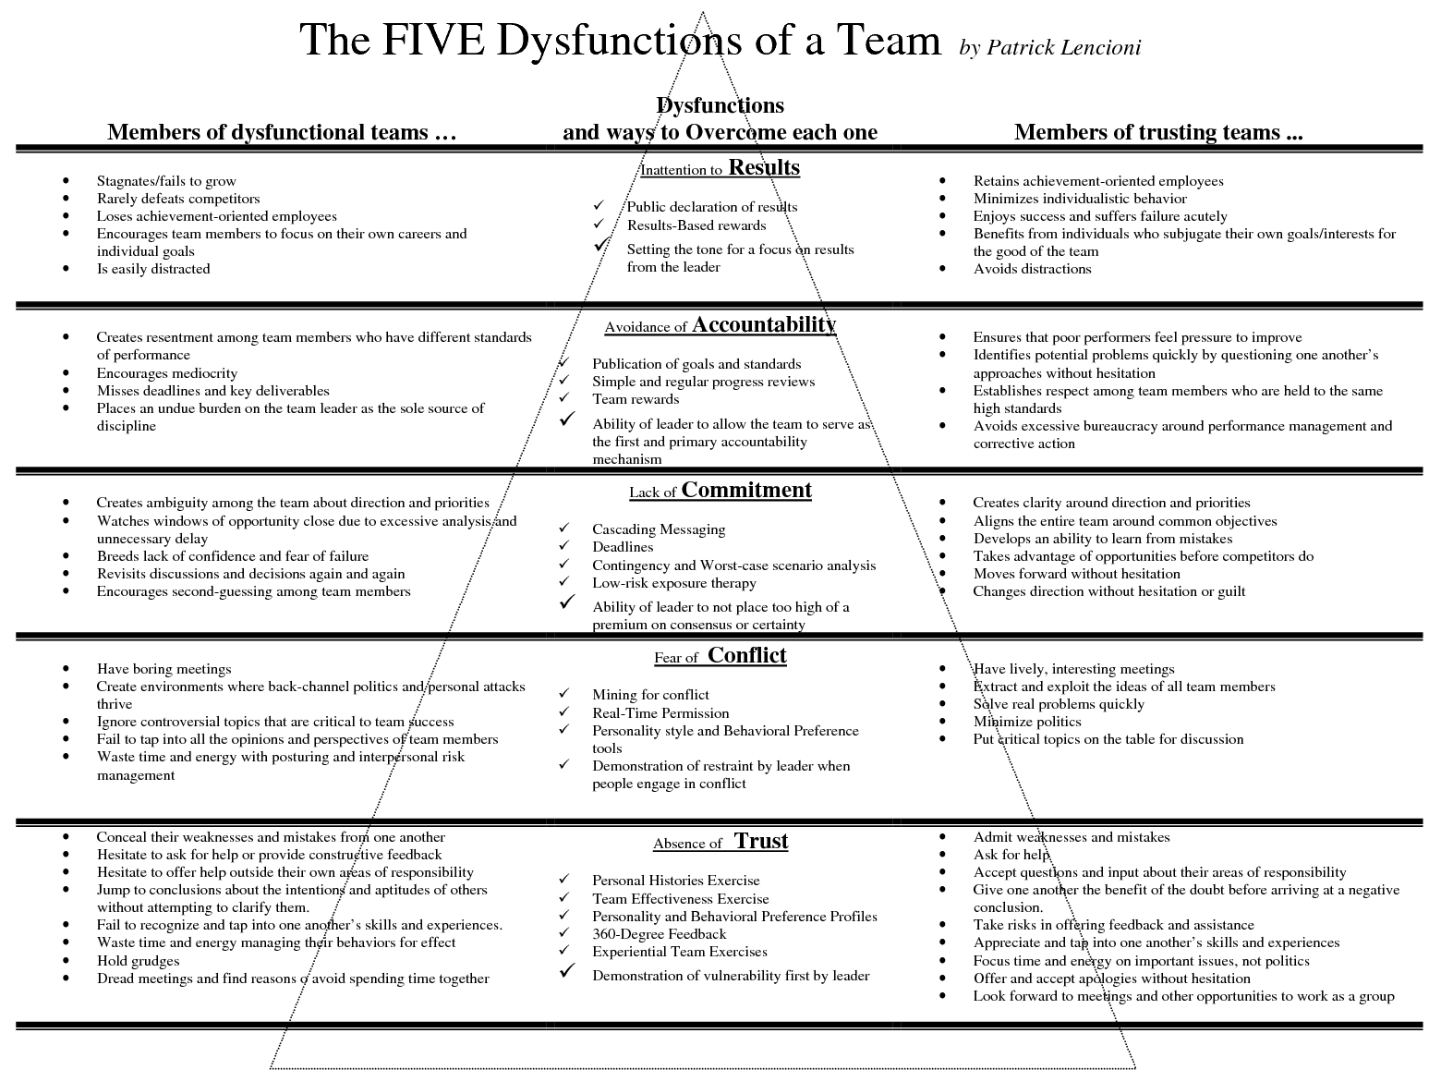
The Five Dysfunctions of a Team is a business book by consultant and speaker Patrick Lencioni first published in 2002. It describes the many pitfalls that teams face as they seek to "grow together". This book explores the fundamental causes of organizational politics and team failure, and might give practical guidelines on how to steer the process within your PREMIUM team by enhancing trust in your team.

6.4 Tools and games available at EDLAB
Always try to prevent any issues from escalating within the team. Give each other constructive feedback and respect each other’s (cultural) differences. This goes for the students, but also for example for your client. Most issues arise when there is no clear communication and a good conversation and clear agreements more often than not will help to clear the air. Sometimes a proper feedback session is needed to get the team back on track, clear the air, or just to see where you all stand as a team. Making time for such a session shows reflective skills and professionalism in teamwork.
In order to facilitate such a session, EDLAB has a large variety of tools, games and instruments available that you may use or borrow for a session. Below two examples, but we have many more!
- Feedback³ is a set of 7 cubes that will help make your feedback session easier, more natural and fun! Each of the cubes addresses a topic that should be addressed when talking about the team process, ensuring that all of the important issues will be discussed.
- Beeld & Box: Each image card contains a photo that evokes associations and thoughts. The strength of this tool lies in its many application possibilities. Working with the image cards is recommended for anyone looking for a way to visualize thoughts and processes and share them with others.
- New Perspective Game: You are probably familiar with the situation where an existing issue could use a fresh, new perspective. What if you can achieve this by playing a fun card game together? 'The new perspective game' contains cards in different categories, creating new twists in the game. The game always ends with a new perspective. On to a fresh start!
- Core Quadrant Game: A unique and inspiring way to get to know yourself and others. By means of 128 playing cards you can compose countless core quadrants each consisting of a core quality, a pitfall, a challenge and an allergy of yourself or somebody else. Each card is elucidated by synonym and a popular saying. This bestselling game is based on the core quadrant model described in the bestselling books Fancy Meeting Me Here! and Core Qualities and the Core Quadrant by Daniel Ofman. In The Netherlands alone more than 25.000 copies of this game were sold so far.

Chapter 7: Coach and Mentor Training Programme
PREMIUM organizes a yearly series of professional workshops and supporting activities for Coaches and Project Mentors, with the following objectives in mind:
- Establishing uniformity in coaching approaches and techniques for the students (minimum level of quality the students can and may expect);
- Establishing uniformity in techniques for Project Mentors to support the students in an appropriate manner in their project execution (minimum level of quality the students can and may expect);
- Offering a platform for exchange of experiences and best practices;
- Facilitating the drive of professionals to grow in their coaching skills;
- Facilitating the drive of professionals to grow in their role as Mentor.
We believe that the knowledge, skills and techniques learned in this programme, are not only useful in the context of PREMIUM but can be transferred to a wider range of professional working environments, such as tutoring students with their thesis or supporting students in the execution of group assignments.
Therefore, this programme for Coaches and Project Mentors in PREMIUM can be beneficial for more students than just those participating in PREMIUM and the organization itself.
An overview of this year’s available trainings and a registration link, can be found on the PREMIUM Coaches and Mentors website: https://edlab.nl/excellence/premium/premium-coaches-and-mentors/
Of course, you will also be kept updated via email.
After having participated in the required number of workshops and activities, coaches and mentors will receive an official certificate signed by UM’s rector, stating they have been active as a PREMIUM coach or mentor and participated in the training programme described in this document. Besides that, these trainings may count towards your CPD, depending on your personal development goals, in discussion with your supervisor or manager.

Chapter 8: Compensation
Coaches and project mentors receive compensation in hours for their participation in PREMIUM.
- Coaches receive 4 hours per student they coach, and 5 hours for facilitating a Team Kick-Off session and a midterm Team Dynamics session.
- Mentors receive 20 hours per project team.
The standardized and maximized compensation fee is € 80 per hour.
We need to follow your faculty regulations in this (transferring the compensation either to the faculty appointed budget number or to a personal budget number, or solver hours/BROS).
We require an honours mentality of our students, and needless to say, we ask the involved Project Mentors and Coaches to display exemplary behaviour. Meaning that you partake in the training programme elements, guide the students to your best knowledge and communicate regularly with the PREMIUM Central Management Team.

Chapter 9: Contact information
For information that cannot be found in this handbook, please contact the PREMIUM Central Management Team or the PREMIUM Coordinator at your faculty.

PREMIUM Central Management Team
EDLAB |  | Fabienne Crombach, Senior Coordinator  premium@maastrichtuniversity.nl
EDLAB |  | Anna Ivanova, Coordinator  premium@maastrichtuniversity.nl

PREMIUM Faculty Coordinators
Faculty Coordinator |  | Email
LAW |  | Carolina Cicati  c.cicati@maastrichtuniversity.nl
SBE |  | Sabine Nievelstein  s.nievelstein@maastrichtuniversity.nl
FPN |  | Sanne ten Oever  sanne.tenoever@maastrichtuniversity.nl
FASOS | 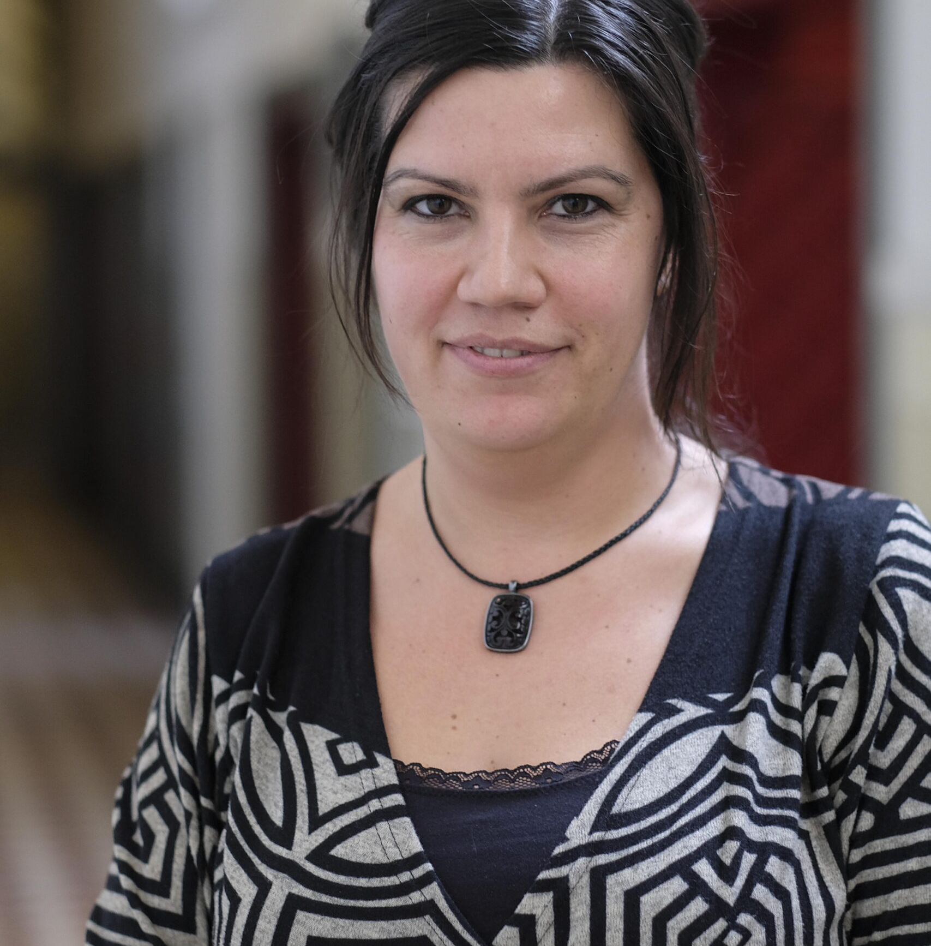 | Elissaveta Radulova  e.radulova@maastrichtuniversity.nl
FHML |  | Jascha de Nooijer  j.denooijer@maastrichtuniversity.nl

Appendix I: Project Scope, Success criteria and Timeline

Step 1: Define the scope of your project.

Origin of your project: a problem or an ambition?
What needs to be solved? Is there a question behind the question?

What needs to be realized?
What has already been tried to solve the question?

Project Goals
Why is this important for the client right now?

What do they want to achieve with your deliverables?

Deliverables
What do you need to give to your client by the end of PREMIUM?
How to best present your results? What suits best within the type of organization of the client?
What IS or IS NOT part of the assignment? Define what’s inside your project, what you will be working on, and what is not part of your project.
What are the constraints the client puts on time, money, people or resources?

Stakeholders
Identity and differentiate stakeholders based on their interest and influence.

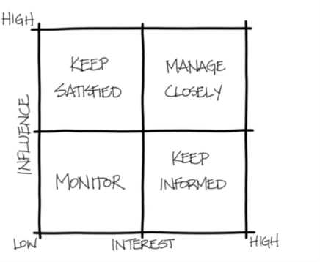

Decide within your team the role of the stakeholders.
(Are you going to research them, or actually involve them in the project? Also
discuss the communication to stakeholders during and/or at the end of the
project.)

Step 2: Indicate success criteria.

Success criteria
By the end of PREMIUM, what would make you happy as a team to have accomplished?
By the end of PREMIUM, what does your client see as a successful end result?
What are the quality standards of the client and the project team? How will you check the quality during the project?

Step 3: Indicate potential risks

Identify the project’s risks
What risks are involved in achieving the desired results?
Which are the most important and have the highest priority, and which the lowest?
What measures will be taken?

Step 4: Timeline

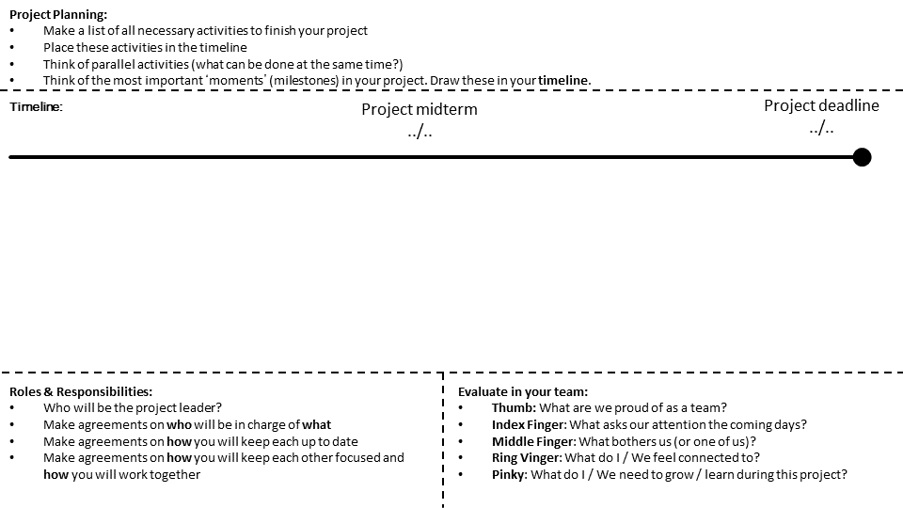

Appendix II: Guideline for setting up a budget

(Preliminary) Budget
Team:
Expense: |  | € | Remarks:
Team building |  | …. | Costs for activity (dinner with team)
Printing |  | …. | Poster for end presentation
Catering |  | …. | Providing catering for client meeting
Unforeseen |  | ….
Total Budget: |  | € 150,00

Date:………………………………………

Approved by project mentor:
……………………………………………….

Transportation Expense: | € | Remarks:
Travel expenses client | …. | Meeting client, forth and back x 2
Travel expenses other | ….
Total Budget: | € …..

Date:………………………………………
Approved by client:
………………………………………………
Appendix III: Team charter
Research on team performance shows that high-quality team charters (written plans for how the team will manage its activities) are positively related to team performance.
Drafting a team charter increases team members’ knowledge of the strengths and weaknesses within the team, helps to create shared expectations, and facilitates the establishment of effective group practices for dealing with high and poor performance.
A team charter is a strategic framework that helps team members to kick off projects and align on common vision. It is made to smoothly start collective projects, let people learn about each other and accumulate enough momentum to get going.

The PREMIUM team charter has two parts

Part 1: The individual part: In which you answer a number of questions about yourself and your expectations with respect to the performance of your PREMIUM team. Part 1 is to be filled out by each team member individually prior to the “Team Kick-Off” session.

Part 2: The team part: In which you discuss together your team roles, expectations and processes. You fill out the team charter as a group during your “Team Kick-Off” session.

Part 1: Individual preparation
Please fill out this part of the team charter individually, before your “Team Kick-Off” session.

Your individual profile

People & Roles: Please provide some information on your personal background (e.g. where you grew up, what courses you have followed, hobbies, personality traits).
People & Roles: What are your preferred working styles, particularly in relation to teamwork? Please refer to the Belbin team roles.

Goals: What do you consider the criteria/elements of a perfect team?
Personal Goals: What aspect of your personal agenda would you like to open up? (examples: availability conflict during certain period, motive for joining PREMIUM etc.)
Purpose: Why did you prefer this particular project? What expertise and knowledge can you see that might be of use here?

Strengths & Assets: What strengths do you have that can contribute to the functioning of your PREMIUM project group?

Needs & Expectations: What do you need from the team to improve/optimise your individual contribution?

Weaknesses & Development areas: What aspect of personal and/or professional development would you like to work on during PREMIUM?

Weaknesses & Development areas: What do you feel your team members, coach or mentor should know about you?

Your expectations regarding the team
Goals: What would you ideally like to achieve as a team in this project?
Values: What are values that you would like to be at the core of your team? (examples: honesty, relationships, teamwork, profitability, and passion)
Purpose: What do you feel is the purpose and relevance of your team in this project?
Needs & Expectations: What would make this team successful? How is that measured?
Needs & Expectations: What would you expect from your team member’s work ethic? For example, showing up on time, turning off mobile phones, indicating when members will miss a meeting, equal contribution.
Rules & Action points: What rules would you introduce as standard in your team with respect to accountability? (examples: how do we address free-riding, what is considered free-riding, how do we hold each other accountable)
Rules & Action Points: How do you prefer to make decisions in your team, even when working under stress?
Rules & Action Points: How do you prefer to communicate in a team and ensure all stakeholders and team members are updated?
Weaknesses & Developments areas: What obstacles for your team do you believe your team might likely come to face?

Part 2: Team roles, expectations and processes
In Part 1, each student answered the questions individually. During the “Team Kick-Off” session, the idea is to come up with collective answers/decisions for all questions/themes.

Team performance
People & Roles: Team name
People & Roles: Roles we have in the team
Purpose: Why are we doing what we are doing in the first place?
Goals: What do we want to achieve as a group?
Goals: What are our key goals that are feasible, measurable and time-bounded?
Personal Goals: What are our individual personal goals?
Personal Goals: Are there personal agendas that we want to open up?
Values: What do we stand for, what are our guiding principles?
Values: What are our common values that we want to be at the core of our team?
Needs & Expectations: What does each of us needs to be successful in this team?
Needs & Expectations: What are our personal needs towards the team to be at our best?
Needs & Expectations: What work ethic do we expect from each other?
Needs & Expectations: How do we ensure our team is a safe space for all team members? How do we build trust? How do we go about holding each other accountable without compromising the safe space?

Rules & Action Points: What are the exact rules we want to introduce after doing this session?
Rules & Action Points: How do we communicate and keep everyone up to date?
Rules & Action Points: How do we make decisions?
Rules & Action Points: How do we execute and evaluate what we do? Think of celebrating achievements, overcoming setbacks. What is considered a success, a setback etc.?
Strengths & Assets: What are the skills we have in our team that will help us achieve our goals?
Strengths & Assets: What are interpersonal/soft skills we have?
Strengths & Assets: What are we good at, individually and as a team?
Weaknesses & Development Areas: What are the weaknesses we have?
Weaknesses & Development Areas: What should our team members, client, coach or mentor know about us?
Weaknesses & Development Areas: What are some obstacles we see ahead of us that we are likely to face, and how do we propose to overcome them?

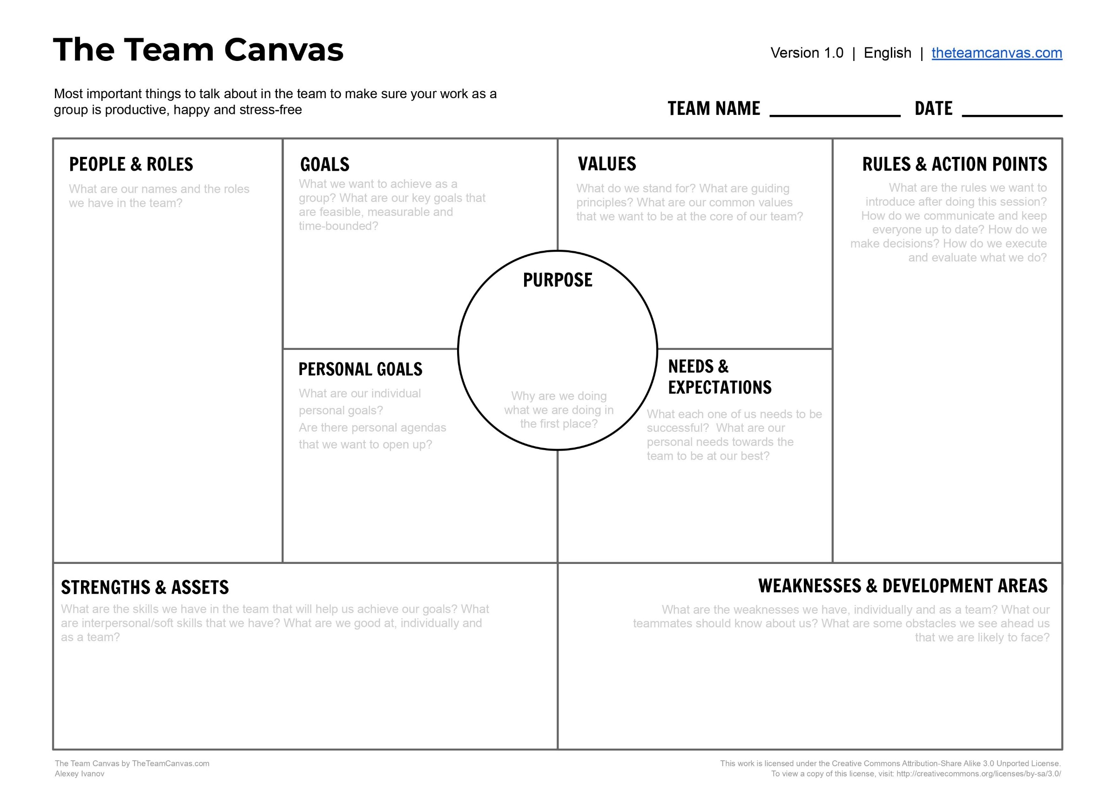
Appendix IV: PREMIUM Midterm Project Review Form
Fill out this form and submit the filled out form to your Project Mentor, at least 48 hours before the scheduled Midterm Project Review Meeting.
During this meeting, as a team you will discuss the outcomes of this form with your Project Mentor. We suggest you focus on the topics where team members indicated, “disagree”. Highlight both positive aspects and areas where as a team you could improve. By the end of the meeting, you will have made clear agreements on how to proceed working as a team. You have identified what has been working well in the team, and you have addressed what can be improved or adjusted in order to increase productivity, communication, or to adapt to the new working style or the project goals
The following statements address relevant elements for your interdisciplinary collaborative practice within your PREMIUM team. Please indicate whether you agree or disagree with each of the statements,
and provide a short explanation to your answer (use keywords that serve as a reminder for yourself during the session).
Purpose, Goals
I feel that out project plans and goals incorporate expertise from all different disciplines represented in the group. | ☐Agree, because: …… | ☐Disagree, because:…..
I feel that our team’s goals are clear, useful and appropriate to my current academic or professional development. | ☐Agree, because: …… | ☐Disagree, because:…..
I feel that our team is supported by sufficient resources (skills, knowledge, guidance from Project Mentor and Client, time, materials, etc.). | ☐Agree, because: …… | ☐Disagree, because:…..
I feel that all team members are committed equally and/or sufficiently to the team, and have a desire to work collaboratively. | ☐Agree, because: …… | ☐Disagree, because:…..
I feel that all members of our team have a good understanding of our joint plans and goals. | ☐Agree, because: …… | ☐Disagree, because:…..
Responsibilities, Autonomy
I feel that all team members acknowledge each other’s skills and expertise. We divide tasks in accordance, while keeping in mind personal development goals. | ☐Agree, because: …… | ☐Disagree, because:…..
I feel that all team members assume a shared responsibility for team decisions and outcomes. | ☐Agree, because: …… | ☐Disagree, because:…..
I feel that we have a clear understanding of who in our team is responsible for which aspects of the project. | ☐Agree, because: …… | ☐Disagree, because:…..
I feel that within our team we can safely and constructively hold each other accountable for their work. | ☐Agree, because: …… | ☐Disagree, because:…..
I feel that within our team all team members can freely and safely express their opinions (to peers and Project Mentor) about the project and progress. | ☐Agree, because: …… | ☐Disagree, because:…..
I feel that our team experiences sufficient autonomy. | ☐Agree, because: …… | ☐Disagree, because:…..

Communication
I feel that concerns are addressed effectively through regular team meetings and open discussions (also with Project Mentor). | ☐Agree, because: …… | ☐Disagree, because:…..
I feel that our team has developed effective communication strategies to share knowledge and progress throughout the project. | ☐Agree, because: …… | ☐Disagree, because:…..
Our team effectively uses the tools agreed upon to support communication (email, WhatsApp, etc.). | ☐Agree, because: …… | ☐Disagree, because:…..
I trust the accuracy of information reported among team members. | ☐Agree, because: …… | ☐Disagree, because:…..
Decision-making and conflict management
I feel that as a team we can quickly identify and respond to a problem or issue. | ☐Agree, because: …… | ☐Disagree, because:…..
I feel that when team members disagree, all points of view are considered equally and without bias before deciding on a solution. | ☐Agree, because: …… | ☐Disagree, because:…..
I feel that disagreements and conflicts are promptly and constructively addressed. | ☐Agree, because: …… | ☐Disagree, because:…..
I feel that in our team, important decisions are agreed upon by all team members | ☐Agree, because: …… | ☐Disagree, because:…..
I feel that in our team, problems can be constructively addressed and solved without external guidance (such as from the Coach, Project Mentor or Central Management) | ☐Agree, because: …… | ☐Disagree, because:…..

Client Involvement
I feel that we have sufficient meetings with the client and enough information, guidance and feedback has been provided. | ☐Agree, because: …… | ☐Disagree, because:…..
Information relevant to project planning and execution is shared with the client. | ☐Agree, because: …… | ☐Disagree, because:…..
I feel that communication with client is smooth, efficient and constructive. | ☐Agree, because: …… | ☐Disagree, because:…..

Project Mentor Involvement
I feel that our Project Mentor assures/oversees that roles and responsibilities in the project are clearly and equally defined. | ☐Agree, because: …… | ☐Disagree, because:…..
I feel that our Project Mentor helps us in reaching our goals and helps to facilitate the interdisciplinary aspect of the project. | ☐Agree, because: …… | ☐Disagree, because:…..
I feel that overall communication with our Project Mentor is smooth, efficient and constructive. | ☐Agree, because: …… | ☐Disagree, because:…..

Agreements made in the Team Charter
I feel that as a team, we still respect and uphold the agreements made in the Team Charter | ☐Agree, because: …… | ☐Disagree, because:…..
I feel that the agreements in the Team Charter are still in line with our goals and overall team functioning. | ☐Agree, because: …… | ☐Disagree, because:…..
I feel that the roles agreed upon in the Team Charter are respected, and they are still suitable for the team’s way of working. | ☐Agree, because: …… | ☐Disagree, because:…..

Appendix V: PREMIUM Peer Feedback Form
"Watering Flowers"

The art of giving and receiving feedback can be a difficult one to master. You may find it triggering or confrontational, but feedback is essential for development and growth.

In PREMIUM, we encourage the use of both positive and constructive language to foster a learning environment built on trust and openness. Our aim is not to avoid what’s difficult, but to express it with care. We use the "Watering Flowers" principle: a metaphor for nurturing someone’s strengths and supporting their potential.
By focusing on strengths and potential, this approach helps build self-esteem and confidence. People are more likely to take risks and try new things when they feel supported and encouraged. It also fosters a mindset of continuous improvement and growth. People are more motivated to develop their skills and abilities when they receive positive reinforcement. Lastly, encouraging and supporting each other strengthens relationships and creates a positive environment where everyone feels valued and respected.

But watering also means noticing which parts need more attention, structure, or challenge to grow well. Feedback is not just praise, it includes honest observations that help others move forward, though provided with good intentions.

When offering feedback:
- Focus on specific behaviours, not personality;
- Be sincere, not flattering;
- Do not avoid areas that could improve, but phrase them constructively as opportunities for growth;
- Giving constructive feedback is not unkind; it is an investment in someone’s development.

This form is your chance to help your teammates, and yourself, understand where they are already blooming, and where more “watering” might help.

Instructions:
- Fill out a form for every member of your PREMIUM team.
- Fill out one self-assessment form on your own performance.
- Focus on highlighting strengths and areas for growth in a constructive manner. Think of your feedback as providing the "water" that helps your peers' "flowers" grow.
- This feedback will not be shared back with your peers, but will be used to foster a positive and supportive learning environment.
- Send all forms to both your Coach and Project Mentor, at least 48 hours prior to the Team Dynamics Session with the Coach. The Coach will discuss the generally provided feedback, patterns they notice based on your feedback, or luring conflicts, during the Team Dynamics session in a safe environment.

Midterm Peer Feedback form:
Filled out by …..(insert your name) for ……(insert your team member’s name)
Nurturing Strengths
 | 🌼 Flourishing | 🌸 Thriving | 🌱 Growing | 🌾 Needs More Watering
1. How did this team member’s contributions help the team achieve its goals? | ☒ Exceeded expectations with outstanding contributions | ☐Consistently met expectations with solid contributions. | ☐Made valuable contributions with room for further development. | ☐ Struggled to meet expectations, needs more support.
Share an example of how this team member’s contributions supported the team’s success.
2. How effectively did this team member apply their expertise and knowledge to the project? | ☐ Demonstrated exceptional knowledge and application. | ☐ Applied knowledge effectively in most cases. | ☐ Applied knowledge with some guidance needed. | ☐ Needs more support in applying knowledge.
Highlight an instance where their knowledge made a significant impact.

Supporting Team Dynamics
 | 🌼 Flourishing | 🌸 Thriving |  | 🌱 Growing |  |  | 🌾 Needs More Watering
3. How did this team member contribute to a positive and collaborative team environment? | ☐ Exemplified outstanding collaboration and communication. | ☐ Communicated and collaborated effectively most of the time. |  | ☐ Showed good collaboration, with room for improvement. |  |  | ☐ Needs more support in team interactions.
Share an example of effective communication and teamwork.
4. How reliable and accountable was this team member in fulfilling their responsibilities? | ☐ Highly reliable and always accountable. |  | ☐ Generally reliable with minor areas for improvement. |  | ☐ Reliable with occasional lapses. | ☐ Needs more support to meet responsibilities.
Share an example of their reliability and accountability.
5. How proactive was this team member in taking initiative and solving problems? | ☐ Frequently took initiative and solved problems creatively. |  | ☐ Often took initiative with effective problem-solving. |  | ☐ Showed initiative occasionally, needs more encouragement. | ☐ Needs more support to take initiative.
Share an example of their proactive behaviour and problem-solving.

Blooming Together
6. Identify areas where this team member can further develop and suggest how they can nurture these aspects.
7. Share something you admire about this team member. Highlight their potential and what you see as an admirable quality.
8. How has working with this team member helped you grow and develop? What could you learn from this team member?
9. What can the team as a whole do to nurture each other's growth more effectively?

Self-Assessment Form
Filled out by …..(insert your name)

1. How would you describe your overall individual performance in PREMIUM and within this team?
(Consider your contributions, collaboration, and engagement.)
2. What is something your team members could learn from you?
(Reflect on your biggest potential and how this helps the team. Knowing your strength has nothing to do with arrogance!)
3. What is an important lesson you have learned about yourself or about teamwork during this project that you want to remember for future collaborations?
(Think of a moment that challenged or surprised you. What did it teach you about how you work with others—and how will you carry that insight forward?)
4. What impact do you think your presence has on the team dynamic?
(Consider how your energy, behavior, or way of working influences the group. This is not about judging yourself but about becoming aware of your role and how you shape collaboration.)

Appendix VI: Final Peer Feedback “Reflections for the Future”

Note: no action required from Mentor or Coach!

At the end of your PREMIUM journey, we invite you to write one final, personal message to each of your team members. This is more than just a nice gesture to conclude your time together, but you should see it as an important part of your own learning process as a future professional.
Throughout your career, you will work in many teams. Being able to recognize others’ contributions and also point out where they can grow is essential to building effective, trusting relationships. By taking the time to reflect on each teammate’s contribution and formulate your message thoughtfully, you practice an essential professional skill: giving feedback that is clear, kind, and constructive. Learning to express both appreciation and honest observations in a respectful way is a cornerstone of effective teamwork and leadership.
This exercise also offers you the chance to look at your own growth more closely. By thinking about what you valued in others and what you learned from them, you gain insight into the dynamics that make teams successful, and you develop confidence in having meaningful conversations about performance and development.
For your team members, receiving this feedback is equally valuable. It gives them an outside perspective on how their presence and behaviour affected the team, and it may highlight aspects of themselves they were not yet aware of. It also shows them that their efforts and qualities were seen and appreciated, while offering them a suggestion or insight they can take forward into future teams. Finally, it lets them know what they taught or inspired in you, reinforcing the idea that teamwork is a shared learning experience.
By taking this exercise seriously, you contribute not only to the growth of your peers but also to your own development as someone who can build strong, trusting and effective teams.

Instructions:
- Fill out the form below for every member of your PREMIUM team (or write it in an email, or any other creative format you want to use).
- Send each team member their form before the deadline of Thursday 21.05.2026.
- Be honest yet kind. Focus on specific behaviours, not personality.
- The goal is to reflect on what your teammate did well, where they can grow, what you learned from them, and to leave them with a warm wish for the future.
- This form is peer-to-peer only, and will remain private between you and your team members.
- You may also choose to share it with your Coach and/or Mentor, but this requires consent from both the giver and the receiver of the final peer feedback.

Final Peer Feedback form:
Filled out by: | For team member:
🌸 What I appreciated about you
Write one or two sentences about what you admired or valued in this person’s contribution and presence in the team.
(What have you admired about this person during this project, which of their qualities will stay with you, how did they make the team or collaboration better?)
🌱 Where you can grow even more
Write one suggestion or reflection about something they could pay more attention to or develop further in future teams. Phrase it constructively.
(Did you notice a quality your team member can develop further to reach their full potential? What could they do to collaborate even better, what habits might hold them back? What would help them succeed at the next level?)
🌼 A wish for your future
Write a short, positive thought, something encouraging or inspiring you would wish for your peer.
(What do you hope your team member keeps doing because it is inspiring? Which of their strengths do you hope the world gets to see more of? What kind of role would really suit them? What do you wish for them in their next steps?)
🌍 What I learned from you
Share one thing you learned from this person that you will take with you into your own future teamwork or professional life.
✨ Closing Thought
As a final note, please share in one sentence how would you describe your team member to someone who hasn’t met them yet?

Appendix VII: Student Checklist with deadlines
Below, we provide you with an overall checklist for every task you need to complete in order to successfully complete PREMIUM. To be specific, if you stick to this checklist, nothing can go wrong, and you should stay on track to get your PREMIUM certificate. Please note that deadlines may be announced or adjusted at a later date. You will always be informed well ahead of time of any deadline or date changes.
  - Team Kick-Off Session (Deadline: Friday February 6th)
    - Together with your Coach (and ideally mentor), schedule and attend your team’s Team Kick-Off session to discuss how the team will work together.
    - Complete the individual section of the Team Charter beforehand and bring it to the Team Kick-Off.
    - Complete the team section of the Team Charter and the canvas together during the Team Kick-Off.
    - Send your filled out Team Charter to your Mentor and Coach after the meeting.

  - Project Kick-Off Session (Deadline: Friday February 6th)
    - Together with your Mentor and Client, schedule and attend your team’s Project Kick-Off session to discuss the project's foundational elements, its content and objectives.
    - Set up a plan for your team meetings (when do we meet, how often, where?)

  - Budget (Deadline: Friday February 6th)
    - Set up a preliminary budget describing the costs you expect to make throughout the project.
    - Send a copy of your preliminary budget to your project mentor (and to your client in case of travelling costs) for approval.
    - In case your client approves your travelling costs, make concrete agreements on how your client will reimburse you (see section on reimbursement).
    - Assign one team member to email the approved preliminary budget to premium@maastrichtuniversity.nl, with your mentor in the CC.

  - Set up the Instagram Page (Deadline: Friday February 6th)
    - Read the chapter on Instagram in your student handbook (Chapter 6).
    - Set up a private Instagram profile for your PREMIUM student team.
    - Send the link to your Instagram page to premium@maastrichtuniversity.nl.
    - Follow the other PREMIUM teams as soon as you receive their profiles.

  - Fill out the form “Project Scope, Success Criteria and Timeline (Deadline: Friday February 13th)
    - Now that you have had time to meet with your client and Mentor, and have had a chance to dive a bit deeper into the proposed project at hand, fill out the form “Project Scope, Success Criteria and Timeline.
    - Send a copy of the form to your Mentor for feedback.
    - Revisit the form and timeline during PREMIUM whenever you need to.

  - First Instagram post: share on your team’s Instagram page the following, in order to inform your fellow colleagues about your team’s PREMIUM journey ahead. (Deadline: Friday February 13th)
    - Introduce your team members;
    - Introduce your client and your project (the scope, relevance of the project, what is asked of you).

  - Register for, and attend, the mandatory workshops (Deadline: Friday February 13th)
    - Attend the workshop ‘Discover your Competences’.
    - Attend the workshop ‘Teamwork & Effective Collaboration’.
    - Attend the workshop ‘Helping Clients Succeed; from Student to Consultant’.

Into the first stages of project execution…
  - First meeting with Coach (Deadline: Friday February 27th)
    - Schedule and attend your first meeting with your Coach.
    - Prepare your PDP Part 1A: Self-Assessment tools “where am I now?”
    - Prepare your PDP Part 1B: “Where do I want to be?”
    - Send your PDP to your Coach at least 48 hours before your session.
  - Second Instagram post: share on your Instagram the preliminary timeline for your project. (Deadline: Monday March 2nd)
    - Explain what is your team’s first approach to the issue at hand;
    - Present the main steps that you are planning to follow in tackling the problem;
    - Present your preliminary methodology.
  - Third Instagram post: share on your team’s Instagram page your progress so far and relevant updates regarding your project. This will be the main point of reference for the teams providing you feedback during the Midterm Presentations. (Deadline: Friday March 13th)

Halfway there…
  - Midterm Presentations (Deadline: Monday March 16th, 09:00hrs.)
    - Read the section on Midterm Presentations in the (online) student handbook.
    - Send in your PowerPoint presentation before the deadline.
    - Attend the Midterm Presentation session your team is assigned to (March 18th or 19th).

  - Midterm Project Review Meeting with Mentor (Between March 9th and April 17th)
    - Schedule and attend the Midterm Project Review Meeting with your Mentor.
    - Fill out the Midterm Review Form, and send it to your Project Mentor at least 48 hrs before the
meeting.

  - Team Dynamics Session (Between March 9th and April 17th)
    - Together with your Coach and team members, schedule and attend your Team Dynamics Session.
    - Fill out a Peer Feedback Form “Watering Flowers” for every member of your team.
    - Fill out one self-assessment form on your own performance.
    - Send the filled out forms to both your Coach and Mentor, at least 48hrs before the session.

  - Second meeting with Coach (Deadline: Friday April 17th)
    - Schedule and attend your second meeting with your Coach.
    - Consult with your Coach which components of the PDP (or other logging method) they would like
to receive from you, and by which deadline.

  - Register for, and attend, three more workshops of your choosing (Deadline: Thursday April 30th)
    - Attend three of the elective workshops.
    - Complete the workshop evaluations.

  - Third meeting with Coach (Deadline: Wednesday May 20th)
    - Schedule and attend your third (and final) meeting with your Coach.
    - Consult with your Coach which components of the PDP (or other logging method) they would like
to receive from you, and by which deadline.
  - Final Peer Feedback “Reflections for the future” (Deadline: Thursday May 21st)
- Fill out a Peer Feedback Form “Reflections for the future” for every member of your team, or write it in an email, or any other creative format you want to use.
- Send each team member their form before the deadline of Thursday 21.05.2026.
- The goal is to reflect on what your teammate did well, where they can grow, what you learned from them, and to leave them with a warm wish for the future.
- This form is peer-to-peer only and will remain private between you and your team members.
Wrap it up!
  - Closing session with the client and Mentor
    - Schedule and prepare a closing session with the client together with your Mentor.
    - Present your final deliverable and reflect on the entire project experience.

  - PREMIUM Closing Event (Deadline: Tuesday May 26th, 09:00 hrs.)
    - Read the section on the Closing Event in the online student handbook.
    - Email your final report, product, or other form of project outcomes to premium@maastrichtuniversity.nl and to your Mentor, before the Closing Event.
    - One member of the student team emails the digital file of the video
premium@maastrichtuniversity.nl and to your Mentor.
    - Attend the Closing Event on May 28th and answer questions from the audience and jury.

  - PREMIUM Evaluation (Deadline: Friday June 5th)
    - Complete the PREMIUM overall programme evaluation.
  - Finalized budget as part of the reimbursement process (Deadline: Friday June 26th)
    - Together with your team, set up the finalized budget that describes expenses your team made throughout PREMIUM. Notify your mentor and client and ask them to approve the budget.
    - Read the section in your student handbook on the reimbursement process very carefully, so that you hand in the reimbursement forms correctly.
    - Hand in reimbursement forms and receipts to the PREMIUM Central Management Team.

Appendix VIII: Basic Emotions
Emotions are not only essential in life; they also give colour to it. Without them, life would be very dull. Emotions work closely together with your cognitive information processing system to steer yourself, the world and others. The five basic human emotions are fear, sadness, happiness, love and anger. Although our emotions can be tricky and inconvenient at times, they can also be our key to more insight into ourselves.
Sadness  (sad, disappointed, mourning, lonely, abandoned) | Sadness is a reaction to loss. This loss can either be great (e.g. the loss of a loved one) or small (e.g. an unkind word from a colleague). Sadness shows us the things we find important in life. After all, you only experience a sense of loss (however small) when it's something that matters to you, in whatever way.
Fear  (scared, wary, tension, panic) | Fear is a sign that there is danger. Our attention span is heightened and we are able to react quicker. Fear makes us alert. In our society, danger can also mean ‘failure’, ‘the risk of losing something’ (e.g. your job).
Anger  (irritation, anger, aggression) | As soon as someone feels anger, they know they have reached their limits. The first light irritation is a sign that someone has entered ‘your territory’. Anger does not only protect us, it also gives us the strength to mark our territory. If someone crosses our boundaries, anger will give us the energy we need to ‘restore order’. By not indicating our boundaries we will only bottle up our anger (which will eventually lead us to having an anger outburst).  It is also possible that someone is mad at themselves!
Happiness  (pleasure, cheerful, positive energy, happy) | Joy is a clear signal that something is happening that is important to us and gives us positive energy. A lot of people are in search of ‘a more satisfying and meaningful life’. This emotion (in all its forms) gives a clear message. What makes you happy in your work? When did you have a good day; what happened? These are good questions for people who are in search of more balance and meaning in their lives.
Love  (friendship, affection, connection/solidarity) | Love connects people. It makes us feel attracted to someone (and it makes us want to reproduce, raise our children etc.). We want to feel connected, not just with our partner and children but also with our friends, colleagues and neighbours. This emotion also gives us more insight into ourselves. If you have enough love and connection in your life, you will have a positive self-image. People with low self-esteem often have more difficulty with loving and being loved than people who do appreciate themselves. It is often said that you cannot love someone else until you love yourself.

Appendix IV: The 24/7 Student or The Perfect Student
The 24/7 student:
The student works hard, is ambitious and always busy.
The ‘perfect’ student:
The student that does not see any areas for personal development and improvement, they can be arrogant and a know-it-all.

How to recognize the 24/7 student:
- Stressed  - Tense  - Task lists  - No time  - Over(re)acting  - Tired  - Well-organized  - Controlling  - Cannot prioritize  - Lack of focus  - Eating habits  - Body language | - Request to develop: time management; working more efficiently  - Worried about what others think of them  - Future oriented  - Task oriented  - Avoids feedback  - Takes control  - Grade/ result oriented  - Will not set boundaries  - Expresses self-criticism  - Experiences the feeling that ‘nothing is good enough’

Underlying motives
Fear of failure/ rejection
Low self-worth
Low self-esteem
Uncertainty
Needs to be loved
Not being good enough.
Time/money pressure
Peer pressure
Need for development/appreciation
Over commitment/responsible

How can you coach perfectionism?
There are many ways to coach a perfectionist. The choice for a certain approach will depend on the person and the circumstances. Below you will find examples of two different methods:

Working with Core Qualities
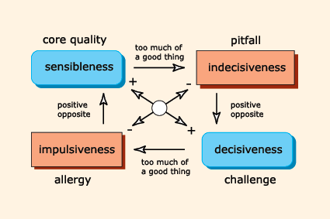

Questions to ask when using Core Qualities
- What is the core quality?
- What irritates you in others?
- What information does this provide you?
- If you are overdoing something, are there many benefits to you in the end? What is then the quality of this? (this is the pitfall)
- What are the risks if the core quality is overdone? / Too much
- What is the core quality of the allergy
- What is the positive opposite of the pitfall?

Time management
What are the three most important things to you in life?
If you focus on work; what are the three most important things to you?
How do you spend your time? Is this in line with your three most important things?
If not, what can you change?
The following is an exercise to give insight into the way we misuse time.
“Do we do the right things for ourselves?” vs “Do we do the right things for others?”
It is important to make sure that you do not forget to spend time on things that are important to you.
Video cast: Work – life balance: https://mu.lms.crossknowledge.com/interfaces/login.php, competence stress resistance, step 2

The “perfect” student
These students often are not aware of their development possibilities.
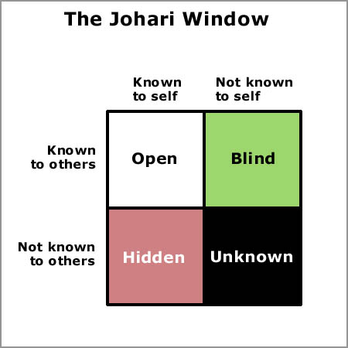
Use 360˚ feedback
Use the core quality’s to discover
Use STARR to reflect on a specific situation
Use openings as:
What is worrying you at night?
What are you proud of?
What is your biggest dream?

Talk with self instead of mind (unorthodox method)
Groundings exercises; walking, meditating (let them breath 3 times will also get them to relax)
Use drawing to let the subconscious rise
Use different perspectives
Use cards, there are a lot of different card-sets available; these are some examples;
Core quality (kernkwadranten), insight, the book of answers, angel cards and many more. You will find them in reform shops like “Tuinen”; bookshops and esoteric shops,

Appendix X: Mirroring
Mirroring is a form of summarising that we can use to examine an issue more closely.
We communicate on three levels;
physically, i.e. body language
tone: what tone of voice is used?
words: what do the words express?
Mirroring is a reflection of your observations on these three levels. You put your own feelings and thoughts on the issue aside, and try to translate the other person’s words, tone and body language into your own words.
Mirroring verbally:
- Someone says enthusiastically: I live in a great house! Mirroring: You really enjoy living in your house!
- Someone says in a bored tone: I live in a nice house. Mirroring: You can imagine living in a nicer house.
Mirroring is a way of translating the verbal and nonverbal input of the other person into your own words. Thus, there is more to it than just summarising. You reflect not only the content of the conversation but also its meaning for the other person and their non-verbal communication; that is, the way they feel about this topic.
If you use this technique well, it can help the other to clarify their thoughts and feelings behind the issue and identify what is really going on, thus serving as a step forward in finding a solution.
Functions of mirroring:
- to give the other person attention and understanding
- to encourage the other to provide more information
- to focus the conversation and prevent you from straying off track
- to give feedback
- to make the situation more relaxed
- to promote a problem-solving approach.

Nonverbal mirroring
If the other person displays a particular attitude and you mirror this quite visibly, this can invite further dialogue and a deeper understanding of what they are feeling. By doing so, you show that you have a strong sense of what the other is communicating verbal as well as nonverbally, and you raise the other’s awareness of their own (sometimes subconscious) body language.

Mathieu, J. E., & Rapp, T. L. (2009). Laying the foundation for successful team performance trajectories: The roles of team charters and performance strategies. Journal of Applied Psychology, 94(1), 90-103. doi:10.1037/a0013257

